**Sleep Study Protocol**

Part I: Somniseal Design Protocol 2

00.A. Somniseal EEG-recording Device Supplies 2

**01.** Logger Diagram 4

**02.** Custom PCB Wiring Diagram 6

**03.** Machined Housing Diagrams 7

**04.** Attachment Diagram 8

**05.** Wiring Diagram (Version 4) 9

**06.** ✍️ Check Previous Iterations 10

**07.** ✍️⚙️Order Supplies 10

**08.** ⚙️Create Templates and Molds 11

08.A. Laser-cut templates: 11

**09.** ✍️Prep Headcap and patches 11

**10.** ✍️Prep Cables for Assembly 11

10.A. Prep SUBCONN Connector 11

10.B. Prep TPU Wires 12

10.C. Solder TPU Wires to SUBCONN Connector 12

**11.** Electrode Prep 12

**12.** Electrode Prep 14

**13.** Potting Prep 15

**14.** Potting Supplies 15

**15.** Potting 15

**16.** Refining potting 16

**17.** Headcap Electrode Configuration 16

**18.** Finalizing Headcap and Patches 17

**19.** Preparing for Deployment 18

Part II: Tagging Protocol 18

**20.** Tag Deployment 20

20.A. Instructions for preparing tag for deployment 20

20.B. Gear Checklist 25

20.C. Attachment instructions 25

**21.** Tag Recovery 30

21.A. Gear Checklist 30

21.B. Removal instructions 31

# Part I: Somniseal Design Protocol

For more information on protocol, read our methods paper:

<https://animalbiotelemetry.biomedcentral.com/articles/10.1186/s40317-022-00287-x>

Kendall-Bar, J.M., Mukherji, R., Nichols, J. *et al.* Eavesdropping on the brain at sea: development of a surface-mounted system to detect weak electrophysiological signals from wild animals. *Anim Biotelemetry* **10,**16 (2022). <https://doi.org/10.1186/s40317-022-00287-x>

[**To see all Tag Supplies with links to manufacturers and supplies, go here.**](https://docs.google.com/spreadsheets/d/11YxVm2u1kR2LZOvjDeegGdl14d07t2NnDEpN34hOT68/edit#gid=0)

***Off-the-shelf or manual construction required:***

✍️ Hand-made or assembled / ⚙️ Automated/machine made / ✍️⚙️  Semi-automated process

|  |  |  |  |  |  |
| --- | --- | --- | --- | --- | --- |
| Somniseal EEG-recording Device Supplies | | | | | |
|  |  |  |  |  |  |
|  | **Item** | **Material** | **Current Supplier** | **Manufacturer** | **Part Number** |
| ✍️ **Headcap/patches** | Reusable Goldcup EEG Electrodes | "No Tangle" Silicone insulation | Natus Neurology | Genuine GRASS |  |
| Neoprene rubber | 1/16" 40A durometer neoprene rubber 12x24 | McMaster Carr |  | 1370N53 |
| Neoprene foam | 1/8 " | Amazon | Lazy Dog Warehouse |  |
| Silicone RTV Permatex Adhesive | Silicone | ACE Hardware | Permatex |  |
| Solder - LABOR |  |  | JKB |  |
| **Custom 3D-Printed Molds** | PLA 3D printed plastic | Patricio Guerrero | 3D printed | Custom design by Patricio Guerrero & Jessica Kendall-Bar |
| ✍️ **Cable Assembly** | Scotchkote / FlexSeal / Liquid Electrical Tape |  |  |  |  |
| Marine-grade heat shrink |  | McMaster Carr |  |  |
| Moisture-Seal Heat-Shrink Tubing, 2:1 Shrink Ratio, 0.25" ID Before Shrinking, 4 Feet long |  | McMaster Carr |  | 74965K63 |
| Moisture-Seal Heat-Shrink Tubing, 3:1 Shrink Ratio, 0.19" ID Before Shrinking, 4 Feet long |  | McMaster Carr |  | 7861K52 |
| Moisture-Seal Heat-Shrink Tubing, 2:1 Shrink Ratio, 0.5" ID Before Shrinking, 4 Feet Long |  | McMaster Carr |  | 74965K65 |
| P/N 103-063-012 .375 316L 316 Stainless Steel Microfilament Pull-On shielding material | 316 Stainless Steel | Glenair | Glenair | 103-063-012 |
| ✍️ **Connector** | SubConn 21 Contact, Female Micro Bulkhead Connector, Brass (WHITE WIRES) |  | Ocean Innovations | MacArtney | MCBH21F |
| SubConn, Micro Series, Inline, Male, 21 - Contact, w/2' of P21C20#OS |  | Ocean Innovations | MacArtney |  |
| Locking sleeve for connector |  | Ocean Innovations | MacArtney |  |
| Potting Compound |  |  | EPOXIES | 20-2180 (2-part) |
| Potting - LABOR |  | Ocean Innovations | JKB |  |
| Solder - LABOR |  | Ocean Innovations | JKB |  |
| ✍️⚙️ **PCB for Logger** | Omnetics Connector |  | Ethan Slattery/digikey | Omnetics | A79024 |
| PCB Fabrication |  | Ethan Slattery | OSH park PCB manufacturing | Custom designed by Ethan Slattery & Jessica Kendall-Bar |
| JST SRSS connectors for connection to bulkhead |  | Ethan Slattery |  |  |
| Design Time |  | Ethan Slattery |  |  |
| Fabrication Time |  | Ethan Slattery |  |  |
| ⚙️ **Neurologger** | Neurologger 3, 3D accelerometer, 3D gyroscope, 3D compass, microphone with sampling rate up to 200 kHz, microSD memory card 128GB, Real-time Clock and Watchdog Timer |  | EvoLocus | Alexei Vyssotski |  |
| Pressure Sensor 4LD |  | EvoLocus | Keller Druck | Transmitter PA(A)-4LD (Drawing #10-0425-140) |
| Neurologger Breakout board (optional) |  | EvoLocus | Alexei Vyssotski |  |
| Lithium Thionyl Chloride Batteries |  | PowerStream |  | ER34615M |
| Solder - LABOR |  |  |  |  |
| ⚙️ **Housing** | Housing tray insert (3D printed) | PLA 3D printed plastic | Patricio Guerrero | 3D printed | Custom design by Patricio Guerrero & Jessica Kendall-Bar |
| Machined Housing |  | Scripps UCSD Marine Science Development Center | Rob Klidy & Eric Browning |  |
| EST-001_Body 7075 T6 |  |  |  |  |
| EST-002_Lid 7075 T6 |  |  |  |  |
| EST-006 Eye Glass Polycarb |  |  |  |  |
| EST-005 Spacer |  |  |  |  |
| Hard Black Anodize (1 lot) |  |  |  |  |
| ✍️⚙️ **Housing Assembly Parts** | 316 Stainless Steel Nylon-Insert Locknut, M3 x 0.5 mm Thread | 316 stainless steel | McMaster Carr |  | 94205A220 |
| 316 Stainless Steel Hex Nut, Super-Corrosion-Resistant, M2 x 0.4 mm Thread | 316 stainless steel | McMaster Carr |  | 94150A305 |
| Super-Corrosion-Resistant 316 Stainless Steel Socket Head Screw, M3 x 0.5 mm Thread, 8mm long | 316 stainless steel | McMaster Carr |  | 92290A113 |
| Super-Corrosion-Resistant 316 Stainless Steel Socket Head Screw, M2 x 0.4 mm Thread, 8mm long | 316 stainless steel | McMaster Carr |  | 92290A015 |
| Fixed-Tip Retaining Ring Plier with Cushion Grip for Internal Rings, 0.038" Diameter 90 | 316 stainless steel | McMaster Carr |  | 57805A33 |
| Weed-whacker line |  |  |  |  |
| ✍️**Tagging Supplies** |  |  |  |  |  |
| Mesh netting |  |  |  |  |
| Epoxy for tagging |  |  |  |  |
| Velcro cable organizers |  |  |  |  |
| Stainless steel zipties |  |  |  |  |
| Tesa Tape |  |  |  |  |
| AquaSeal Neoprene Cement |  |  |  |  |
| Gorilla Glue Superglue |  |  |  |  |
|  |  |  |  |  |  |

### Logger Diagram

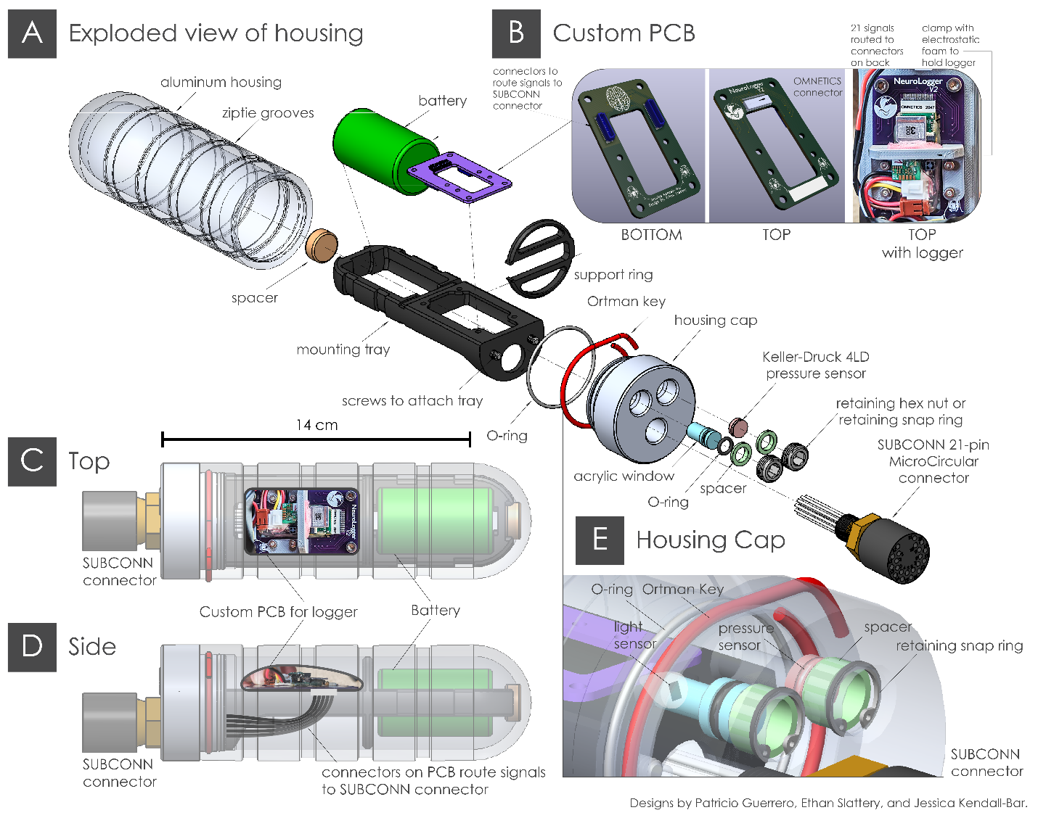

**Custom PCB Version 1-3**

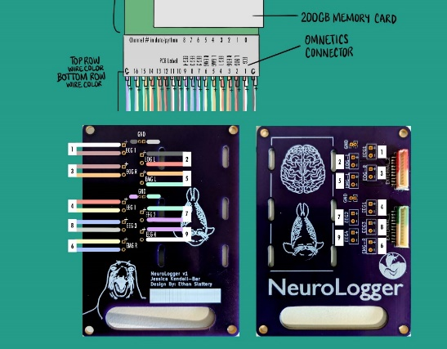 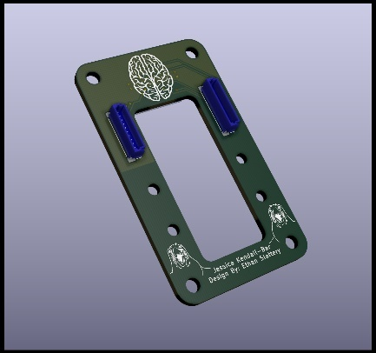 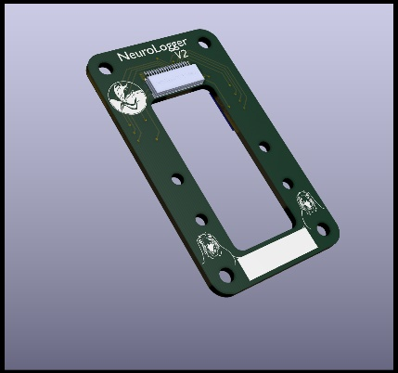

### Custom PCB Wiring Diagram

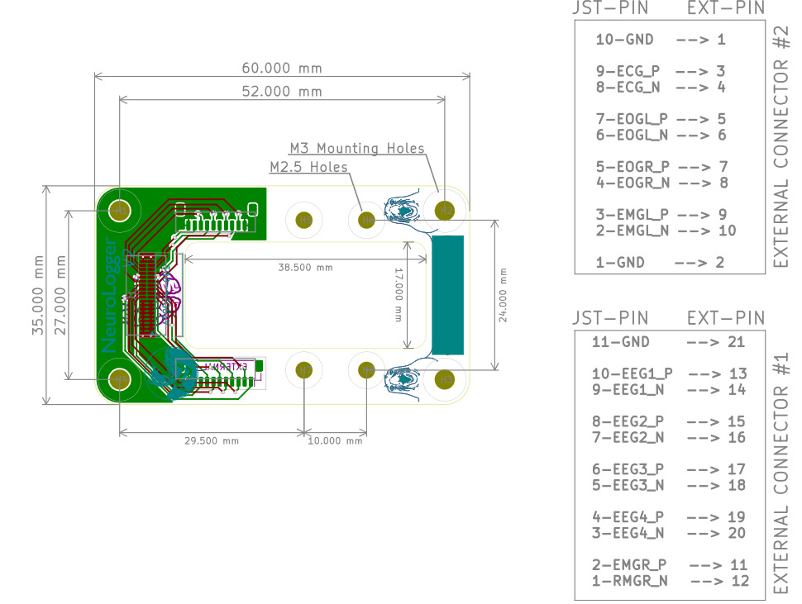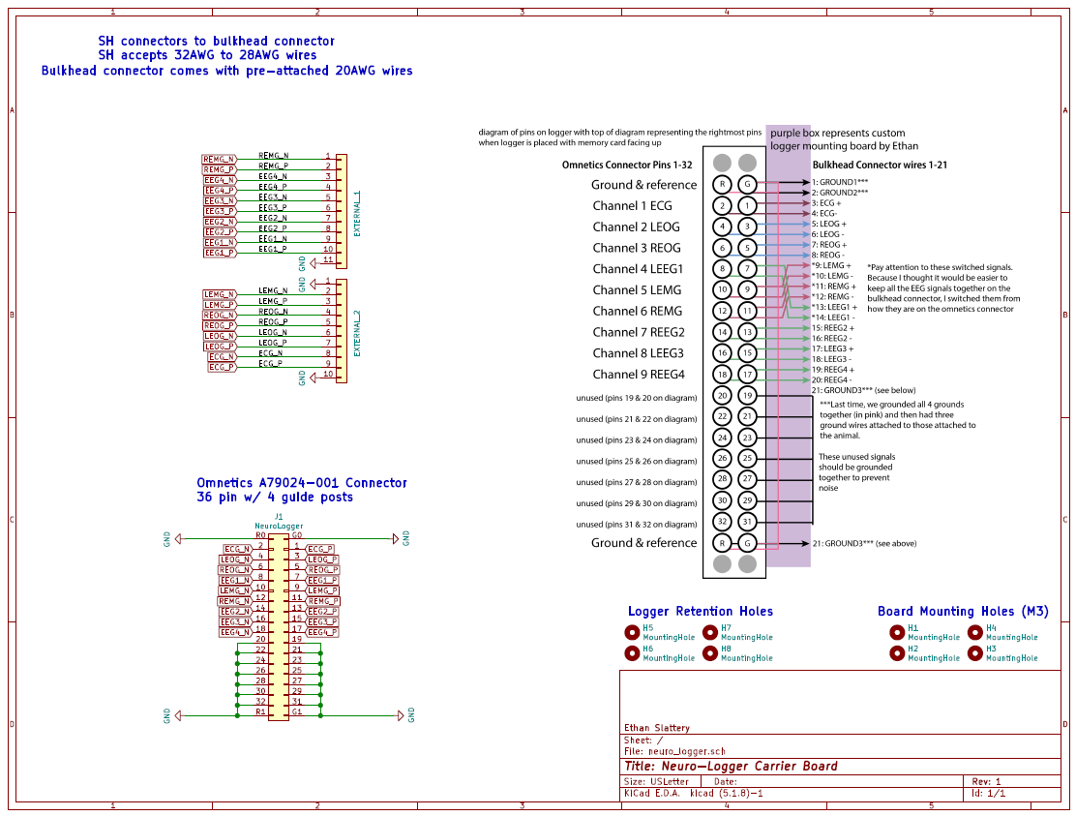

### Machined Housing Diagrams

***Housing Body:***

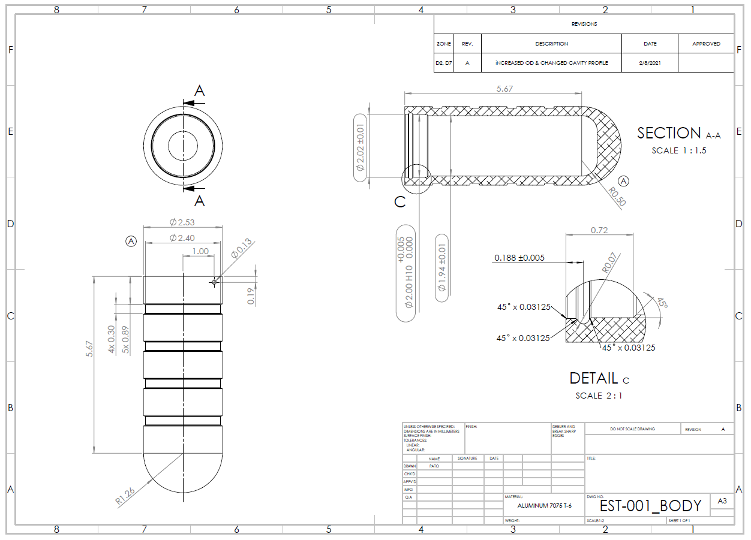

***Housing Lid:***

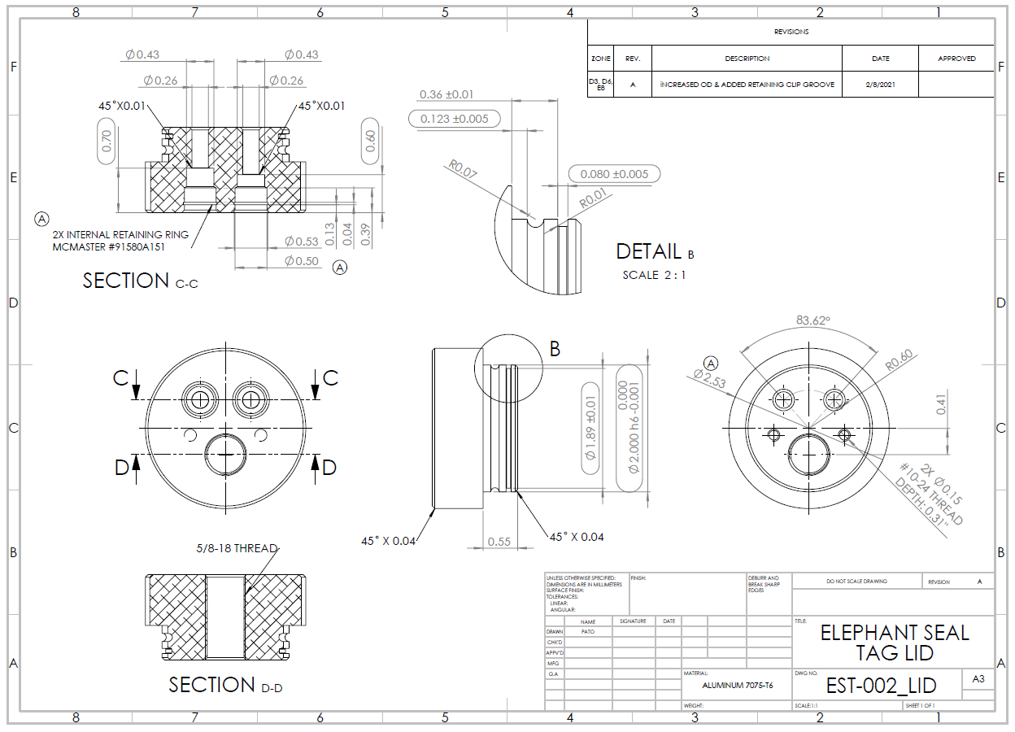

***Spacers*** to hold retaining rings away from acrylic windows:  
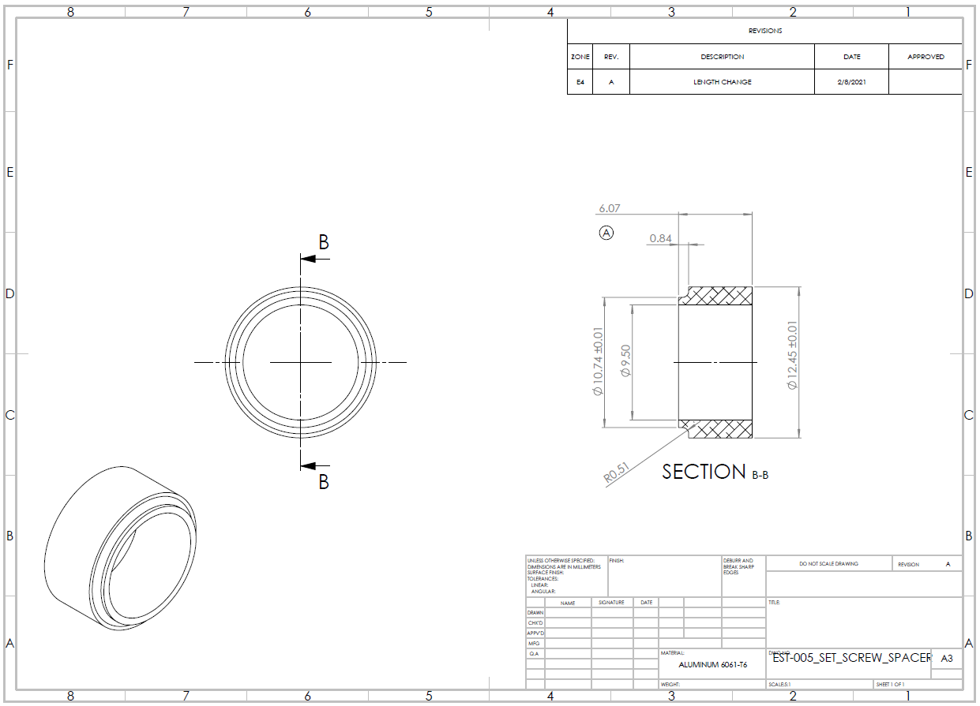

***Acrylic Windows:***  
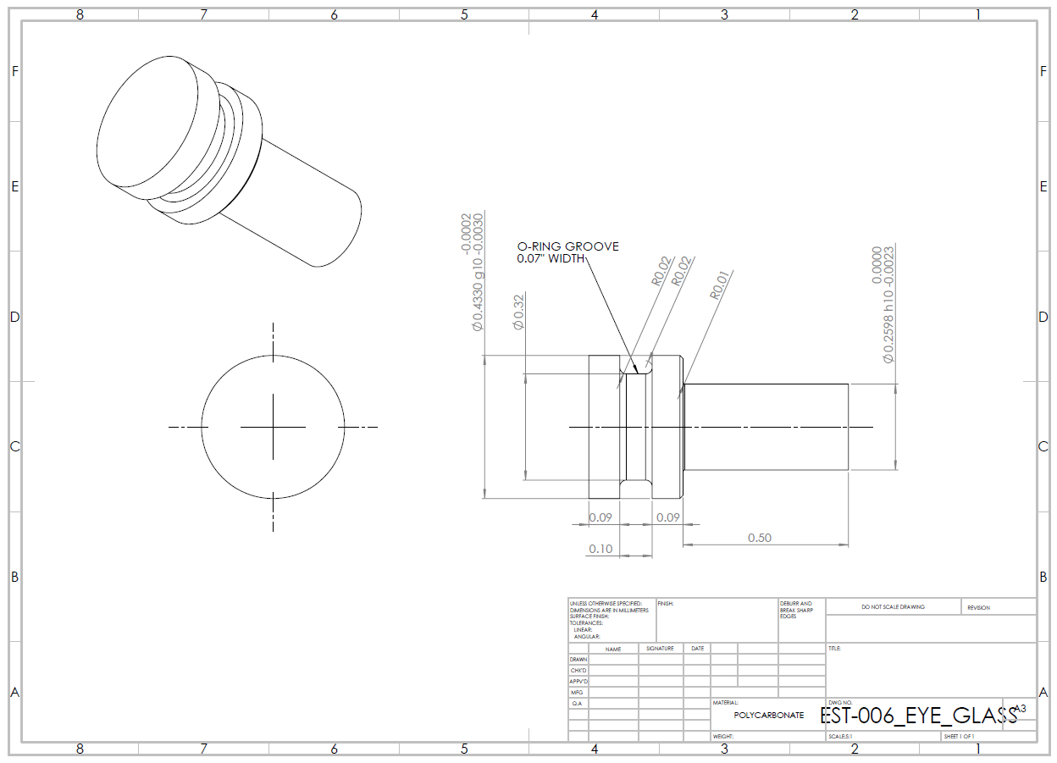

***Lid Close-up:*** Orientation of snap rings and Ortman Groove:  
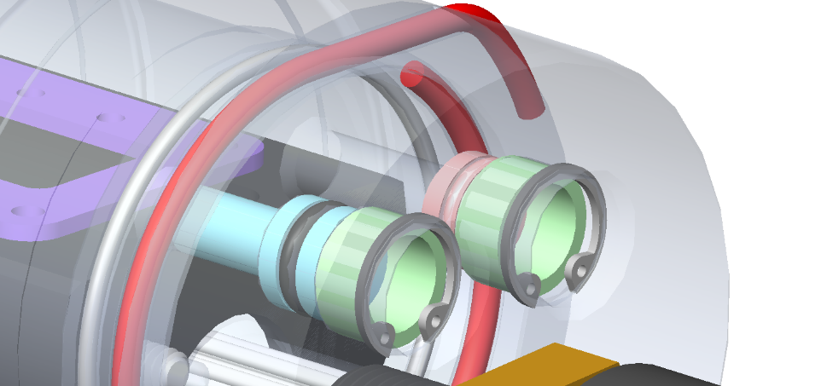

### Attachment Diagram

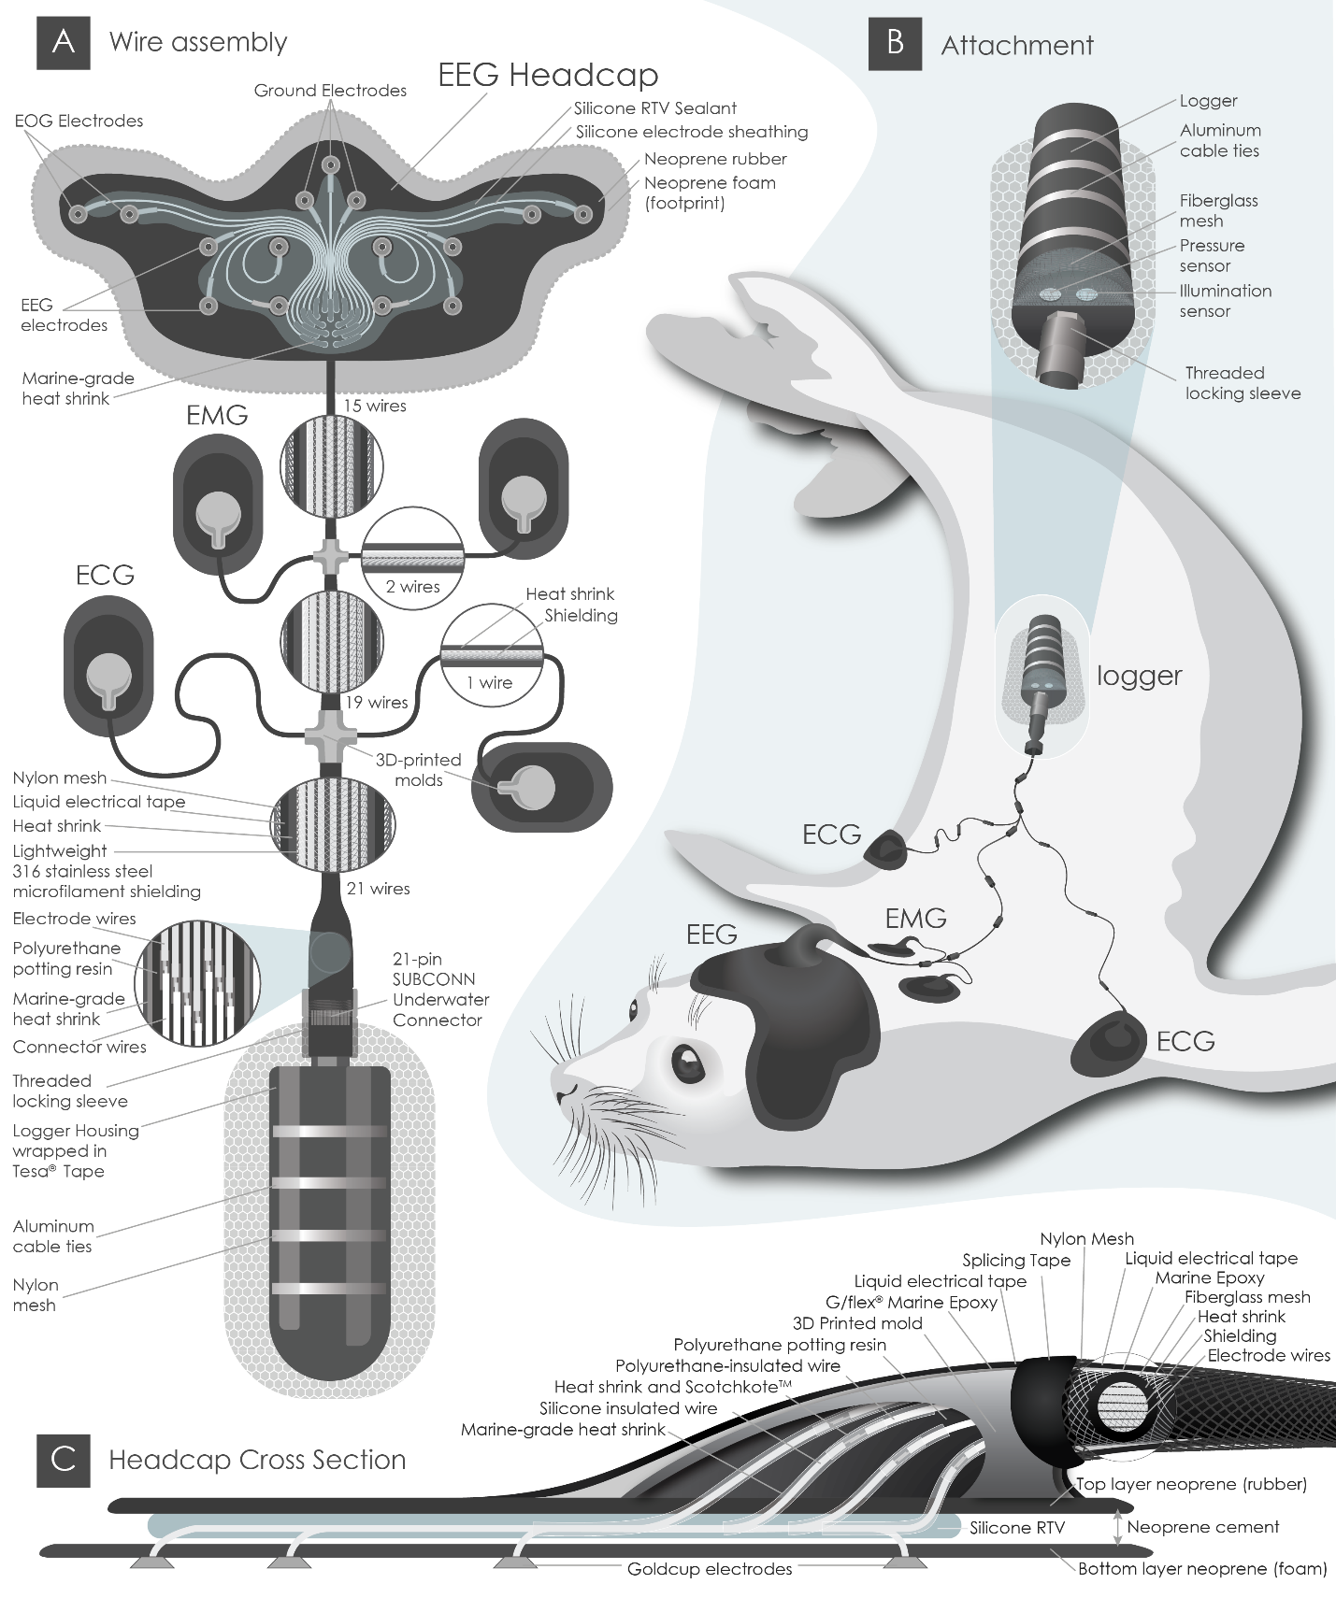

### Wiring Diagram (Version 4)

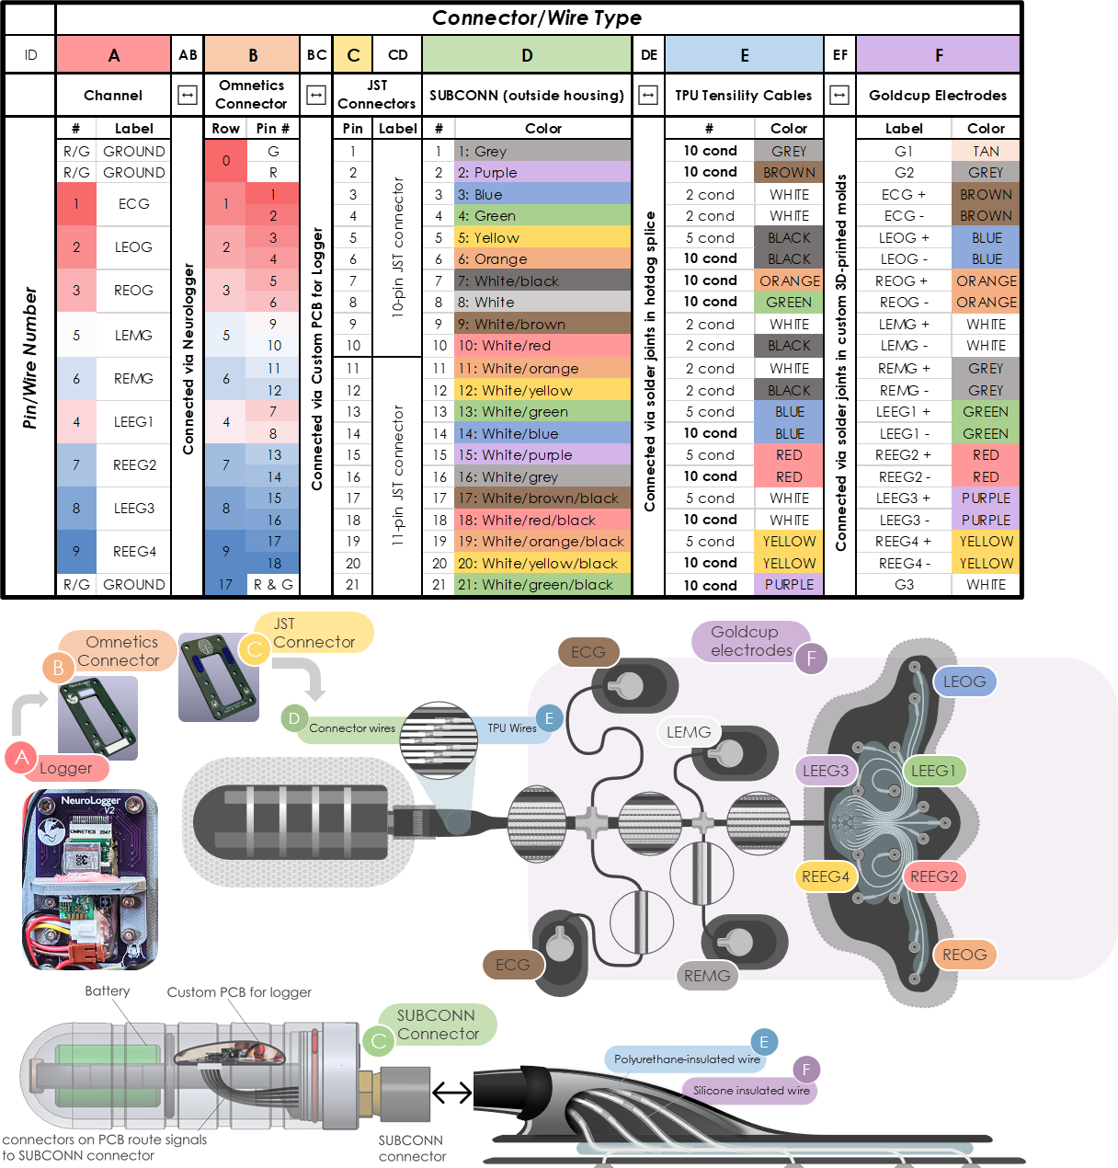

### ✍️ Check Previous Iterations

* 1. Using the wiring diagram, check the connection between the electrodes and wire pins to see where failure points in your design occur.
  2. Record which electrode and pin connections are still connected and record the resistance measured between the pin and the electrode.

### ✍️⚙️Order Supplies

* 1. Follow the Tag Supplies spreadsheet and the table above to order necessary supplies. Update supplies list to reflect desired changes and available suppliers/manufacturers.  
     <https://docs.google.com/spreadsheets/d/11YxVm2u1kR2LZOvjDeegGdl14d07t2NnDEpN34hOT68/edit#gid=0>
  2. Order custom PCB for mounting the logger according to this pin diagram:

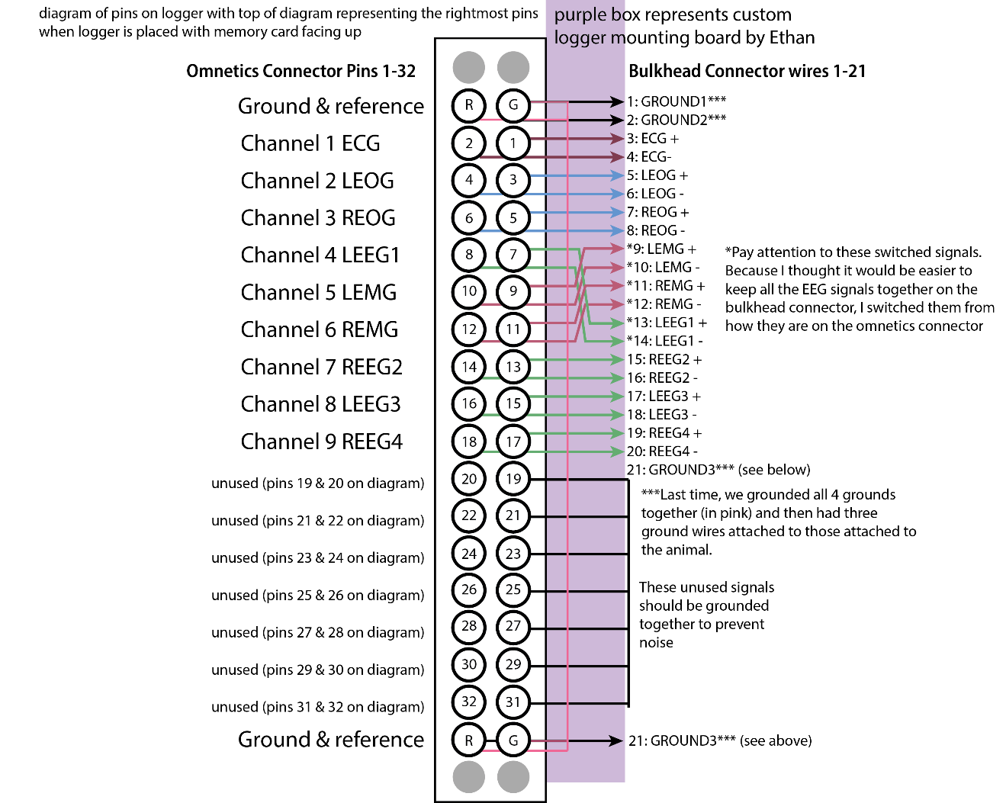

### ⚙️Create Templates and Molds

### Laser-cut templates:

* 1. Create laser-cut template of the headcap using this Illustrator design file.

### ✍️Prep Headcap and patches

* 1. 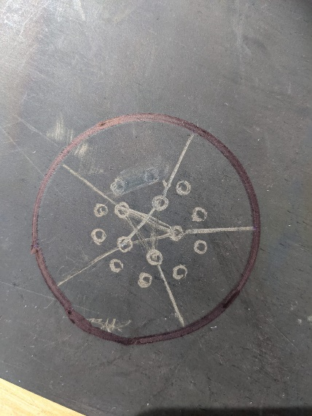Use laser cut headcap template to cut out neoprene rubber (3/32” 40A)
  2. Punch holes through neoprene rubber at electrode outputs
  3. Abrade the neoprene rubber
     1. Using sand paper, rub the neoprene rubber anywhere you are trying to bond other substances to it (e.g. around the edges and the electrode output holes)
     2. If you have a dremel, attach an abrasive tip and use automated sanding tool (don’t sand more than 1/4 of the material away).

### ✍️Prep Cables for Assembly

### Prep SUBCONN Connector

* 1. Using a box cutter, carefully cut cable jacket ~ 2-3 cm from where it tapers to the connector
  2. Remove cable jacket (try to maintain the aluminum foil sheath to ensure wires are not damaged)
  3. Using sandpaper or a Dremel, abrade the cable jacket until the end of the tapered segment (excluding the cylinder with the SUBCONN label).
  4. 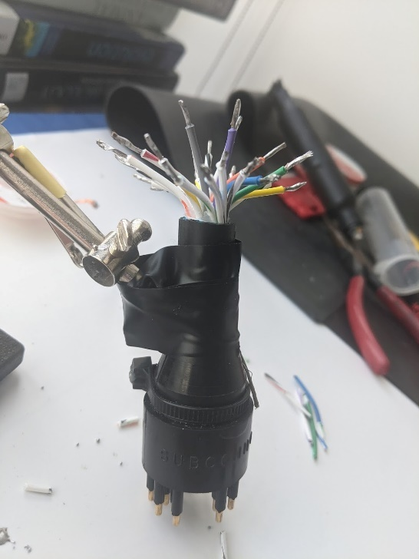Cut SUBCONN wires ~ 1.5cm from the end of the cable jacket.
  5. Strip (0.5 cm) & immediately tin cables with solder to protect the conductors.  
     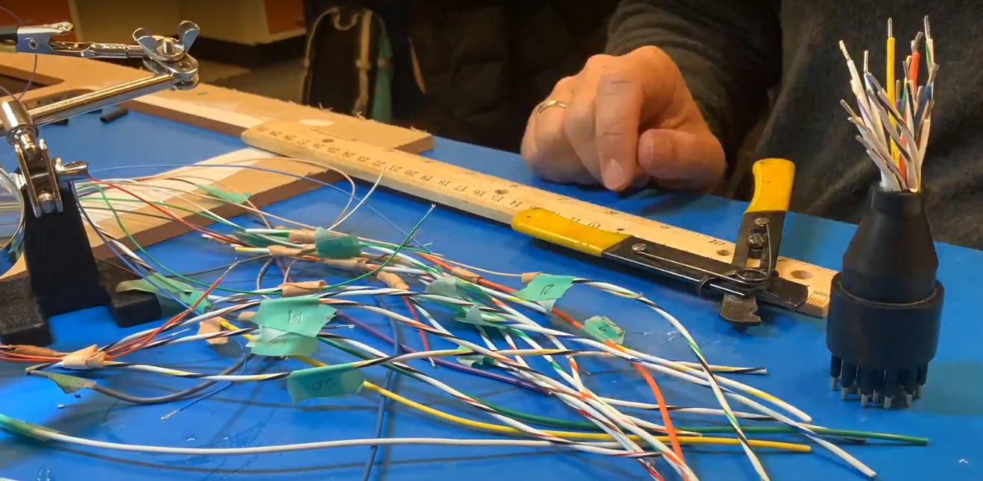

### Prep TPU Wires

* 1. Label Tensility TPU wires & SUBCONN wires with their electrode output
  2. Cut Tensility cables to the correct length (comparing with a previous iteration).
  3. 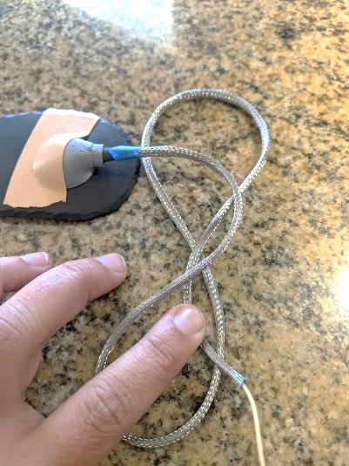Add micro filament shielding to the wire bundles, then add ¼” heat-shrink around wire shielding.

### Solder TPU Wires to SUBCONN Connector

* 1. Strip tensility wires and attach to the subconn pin wires following the guideline of which colors will attach to which electrodes.
  2. Tips for soldering:
     1. Always remember to slide on the heat shrink!
     2. Use marine-grade heat shrink if wires are very different gauges.
     3. Can tin both wires beforehand and then very quickly introduce the solder tip to the wires while holding them against each other (useful for tricky angles).
     4. Check resistance on each wire after soldering
     5. Stripping preferences:
        1. Tensility wires: 22 AWG setting (medium grip)
        2. Silicone Goldcup wires: 14 AWG setting (strong grip)
        3. Teflon Goldcup wires: 20 AWG setting (soft grip)
  3. Post-soldering: inspect connections and apply FlexSeal, liquid electrical tape, or Scotchkote, especially if any conductors were accidentally knicked (check cable jacket region as well as insulation damage/shrinkage from heat).S
  4. 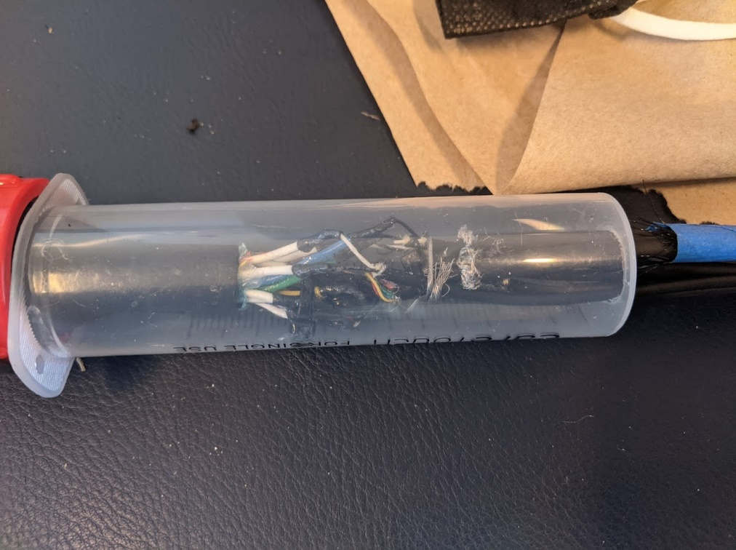Check resistance on each pin after soldering. Write down values.

### Electrode Prep

* 1. Remove heat shrink from electrode-wire connection.
  2. Cover connection in G-Flex (protect electrode from Gflex to avoid obscuring the sensor head/electrode region)
  3. 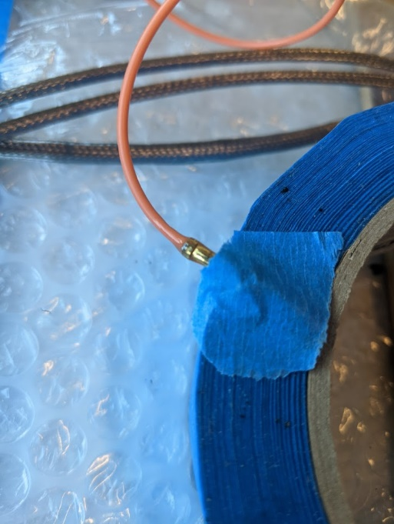While it’s mixed, apply a layer of G-flex over the 3D printed molds  
     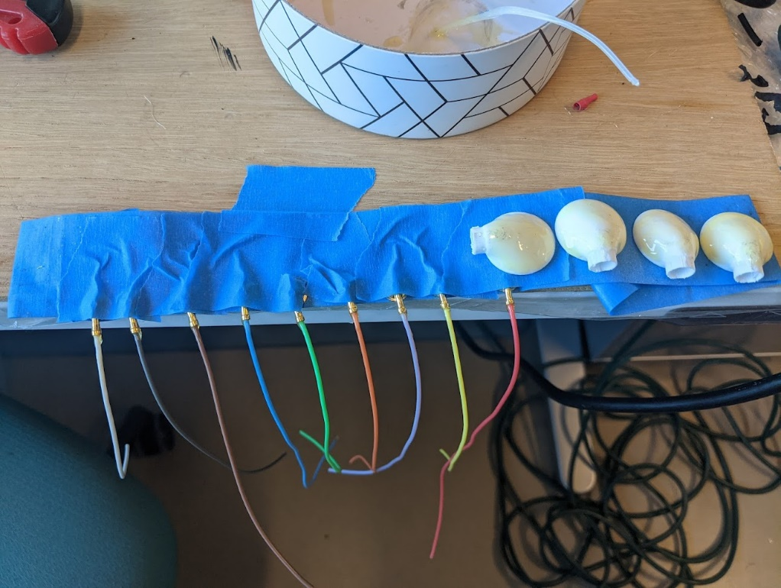
  4. Apply marine grade heat shrink over electrode-wire connection (make sure to use a heat shrink that will bind well with the polyurethane potting epoxy)
  5. Measure and cut electrodes.

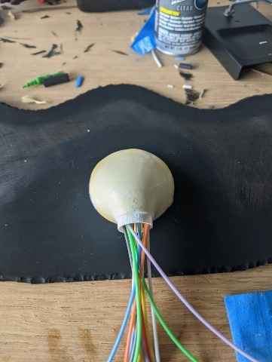 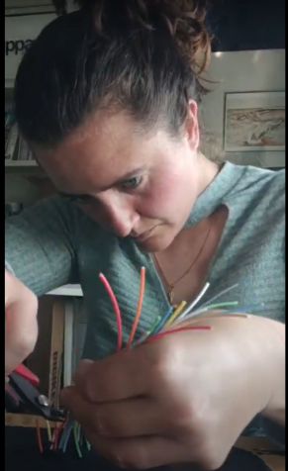 

* 1. Place electrodes where you would like them to rest on the neoprene head cap
  2. Cut the wires so that the solder joint will rest within the molds
  3. String on the 3D printed mold & two pieces of marine-grade heat shrink (one larger gauge to go over all marine grade heat shrink and one to go over individual splice joints)

### Electrode Prep

* 1. 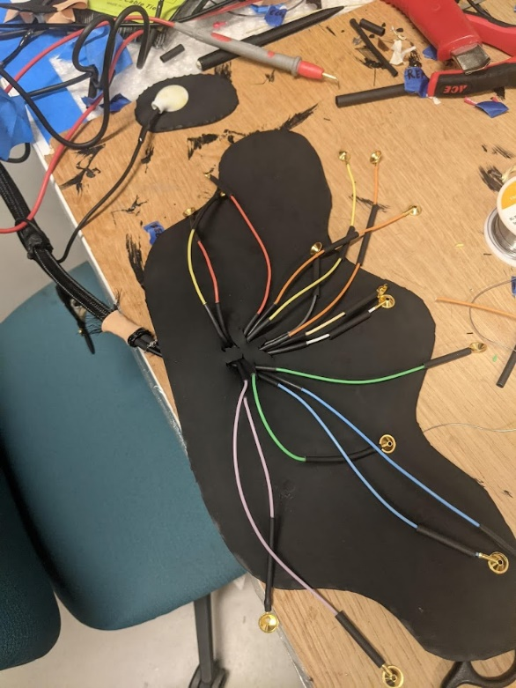Solder the electrode wires to the Tensility wires  
     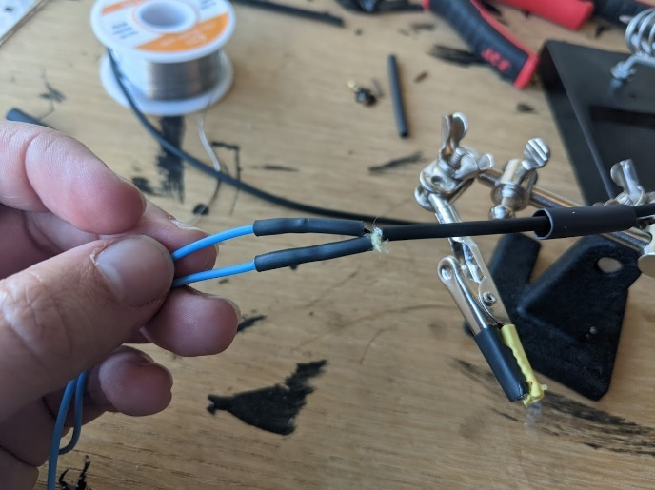
  2. Put g-flex over tensility - shielding - heat shrink junction (just for EMG/ECG wires) so that you prevent water from flowing up into the heat shrink/shielding.
  3. Once you solder all the headcap wires, push them through the holes you created earlier- you may have to cut between the holes to allow electrodes to come through
  4. Fill the holes with g flex to prevent water intrusion into the cap and to prevent potting compound from running into the headcap/patch  
     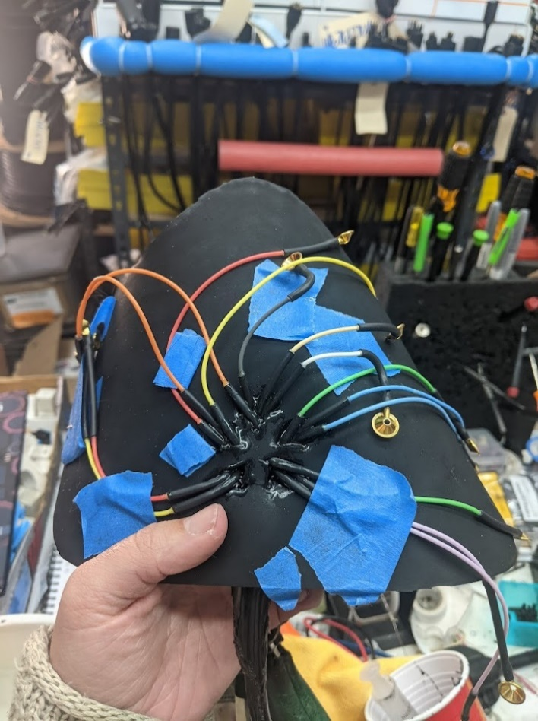

### Potting Prep

* 1. Create molds for waterproofed connections at solder joints:
     1. We used piece of clear, large-gauge heat shrink to create a tapered mold for headcap wire output.

### A picture containing person, blue Description automatically generatedPotting Supplies

* Gloves
* Plastic cup
* Paint mixer
* “A” Solution (Black)
* “B” Solution (Yellow)
* Power drill
* Cotton rag
* Ratio A:B is 1:0.6 or 100:60
* Check weight (calibrate with 500g weight)

### Potting

* 1. 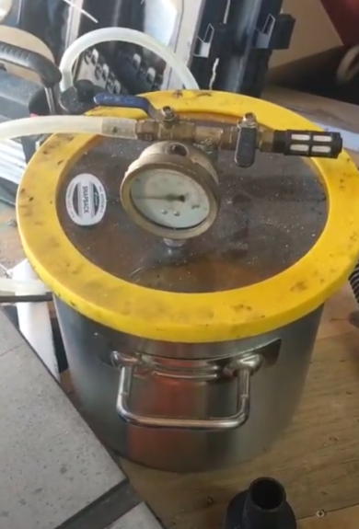Sit flat on table/scale
  2. Use tall 60mL syringe to fill with epoxy
  3. Lab grade isopropyl alcohol (90% or more)
  4. Plastic tip/laur tip for 60mL syringe
  5. Tare/0 weigh the cup
  6. Mix “A” and “B” with the ration 100 A: 60 B
  7. E.g. A=poured 70.5g, B=aim for 42.36g
  8. Power drill attached with paint mixer, mix for one minute, spin bouncing off the walls of cup
  9. Use cotton rag to clean mixer
  10. 45 minutes total to complete pour, put in dispensing syringe
  11. Place cup in vacuum and let set for 5 minutes
  12. Pour down the side of the syringe, piston in, flip over, get rid of any air bubbles in the syringe.
  13. Pour into mold, 5-10% shrinkage. Watch as the epoxy rises to ensure no bubbles are trapped below.

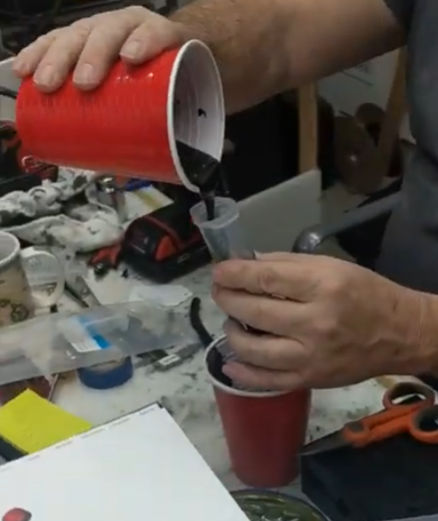 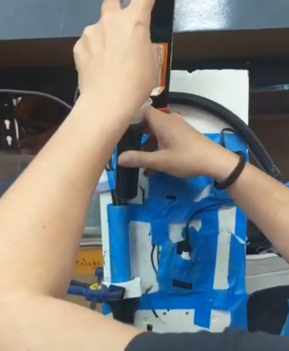 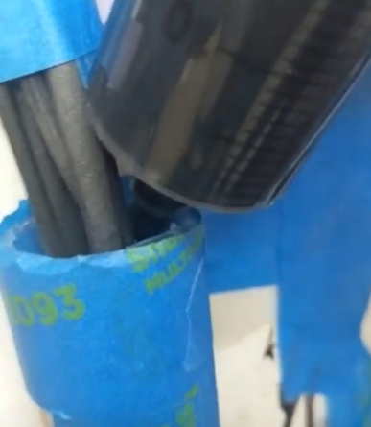 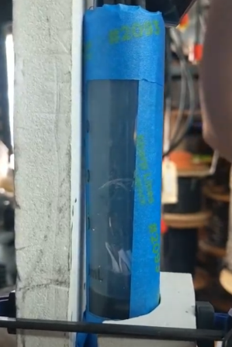

### Refining potting

* 1. Wait 24 hours for potting compound to cure fully – OK to remove syringe etc. the next morning.
  2. Peel off syringe, remove heat shrink, inspect for bubbles.  
     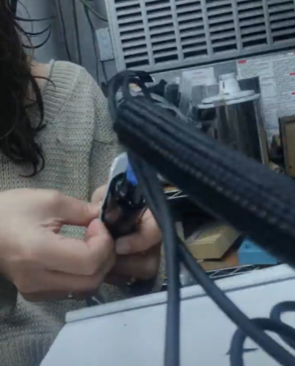 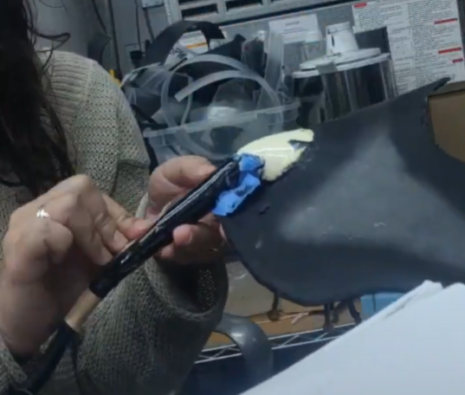
  3. Throughout: check for bubbles in mold, if they are deep, will need to fill holes with more epoxy
  4. Cut, whittle, sand potting compound to a streamlined shape (but take care to not make your cuts too smooth so that epoxy will be able to bond to the surface)
  5. Put a layer of Gflex and fiberglass mesh over your potting compound at any vulnerable connection points (near subconn connector, headcap wire output, and small wire outputs.
  6. Put a 2 inch piece of marine grade heat shrink over the hot dog splice at the subconn connector end, but verify that this won’t inhibit the motion of your locking sleeve, which needs to come back slightly in order to see and connect your pins.
  7. Once the Gflex has cured, use a Dremel to fade the extent of the epoxy-reinforced material (where you would like the material to start conforming to the motion of the animal).
  8. Abrade the Gflex to promote adhesion to its surface.
  9. Cover wire outputs, 3D molds, and exposed cable with liquid electrical tape:  
     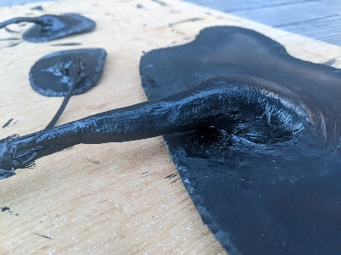 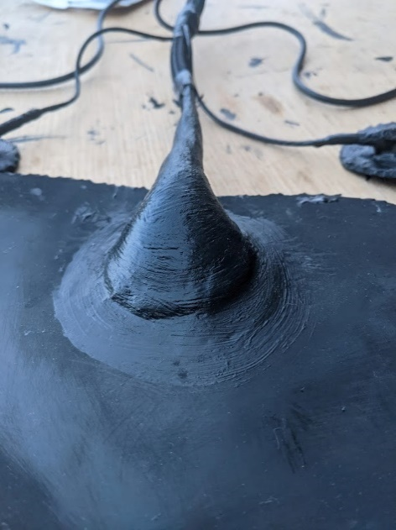 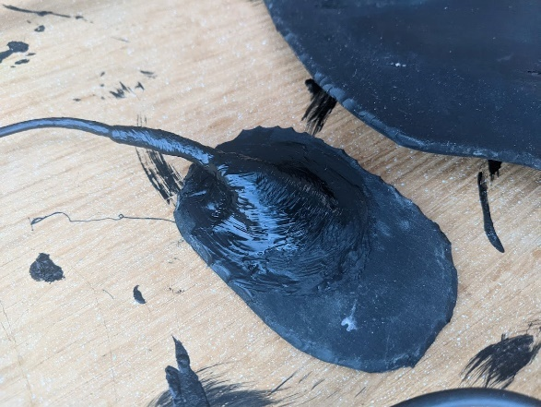

### Headcap Electrode Configuration

* 1. Use silicone RTV adhesive to position your electrodes. Put an initial layer down, wait ten minutes and then place each electrode down. They will (hopefully) stick but you might get your hands all yucky and then have to use a bunch to keep the electrode down against the headcap and then you become a sticky mess. Don't use water to clean up- it will only make things worse. Use (a lot of) alcohol and a rag.

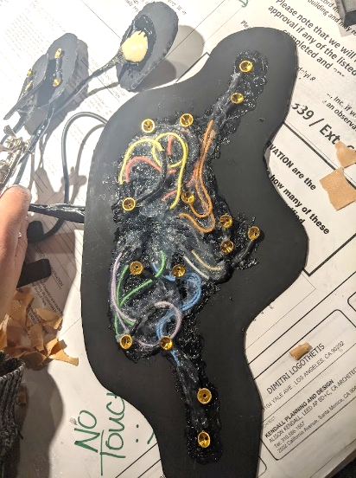 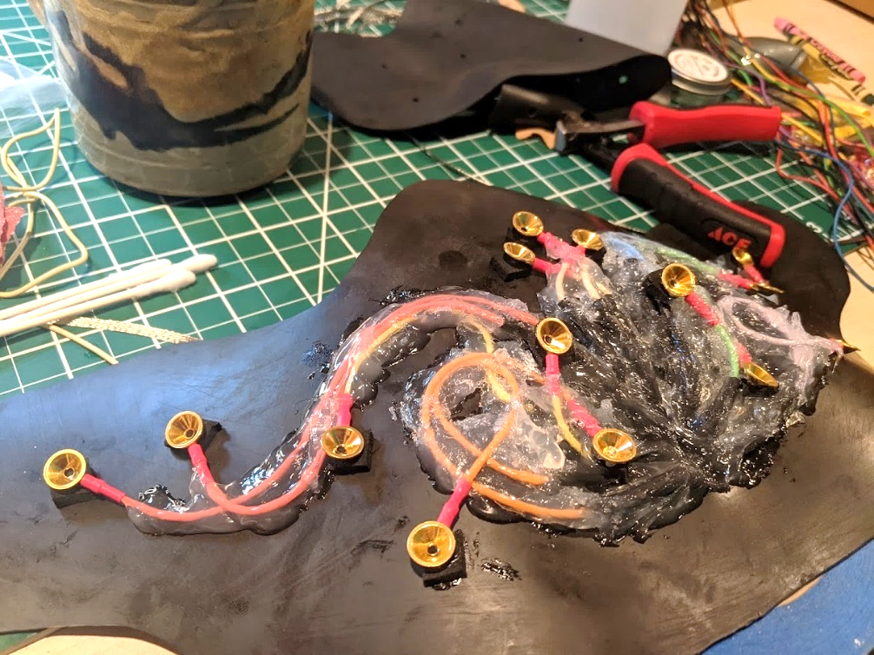

### Finalizing Headcap and Patches

* 1. Prepare neoprene foam layer:
     1. Use template (~3/4 inch larger than neoprene rubber/Illustrator template footprint from Design Step 08) and box-cutter to cut the neoprene foam.
     2. Use ovular template (3/4 inch larger than neoprene rubber patches) for EMG/ECG patches
  2. Prime the silicone for better adhesion:
     1. Around each electrode, use the Silicone RTV adhesive and a brush or Q-tip to create a ring of Silicone RTV for better adhesion to the neoprene. Without this uncured ring, the cured silicone RTV will not bond at all to the neoprene cement and water may be more likely to travel between electrodes and short out signals.
  3. Attach sacrificial layer of neoprene foam:
     1. Slather (a lot) of neoprene cement on both the patches with electrodes and the neoprene foam.
     2. **IMPORTANT: for the headcap, ***before you attach the full-size footprint,*** it is important to attach two layers of thicker neoprene foam on either side of the wire output (which is rigid) to better conform to the round shape of the head (see photos below of first layer [left] and second layer [right]):  
        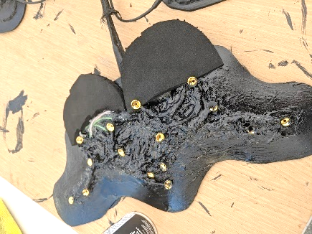 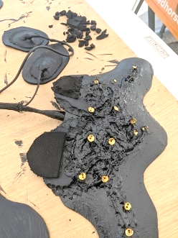
     3. 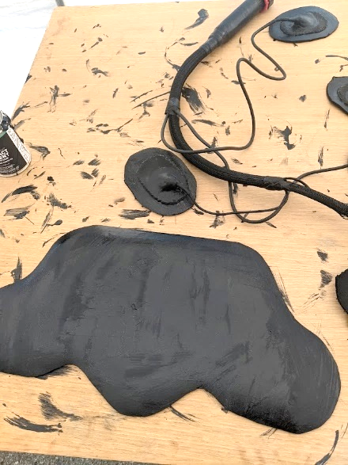Wait at least 4 min for the neoprene cement on either side to solidify/tack-ify. Before the glue is ready, it will come off on your fingers and smear when you touch it. When it is ready, you will touch it and feel it pull on your finger. It should look like this when it is ready:  
          
        *Note: you will notice there are no holes in this neoprene foam layer- that is intentional. You will be able to push each goldcup electrode through the neoprene foam after it is stuck, and this will give you a tighter waterproof seal around each electrode.
     4. 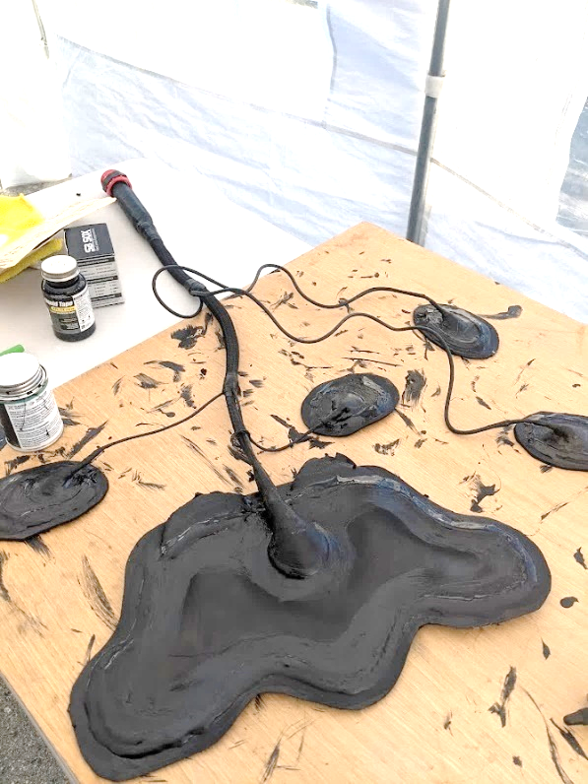Carefully place the neoprene layers together (once they are stuck they are really stuck). It helps to start forward to back, making sure to minimize air bubbles along the way.
     5. Before too long (will become difficult the longer you wait), push each goldcup up and through the neoprene foam. This is a good opportunity to remove any residual neoprene cement on the gold sensor heads (should come off fairly easily).
     6. Place small dots of superglue around the periphery of the cap, where the neoprene rubber meets the neoprene foam. This is a spot where the two layers are most likely to come undone.
     7. To ensure some flexibility, paint a contour of neoprene cement over the dots of superglue (with a brush you are ready to throw away).
     8. Next, place a contour layer of E6000 around the edge of the neoprene foam/rubber interface.
     9. 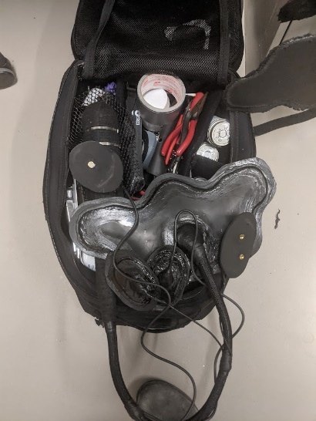Before the E6000 dries, paint another layer of neoprene cement over the E6000. Without this, the E6000 does not make a good enough seal with the neoprene cement and starts to peel off after prolonged water submersion.

### Preparing for Deployment

* 1. Cover exposed cables with nylon sheathing to protect from abrasion
  2. Use splicing tape and/or liquid electrical tape for additional abrasion resistance and attachment
  3. Set up cable-organizing Velcro bridges and prime with a layer of neoprene cement to facilitate adhesion upon attachment.
  4. Follow steps in Part II to prepare logger for deployment and attachment.

# Part II: Tagging Protocol

Steps for preparing for a procedure including configuring, turning on tags, and attaching tags. Notes on animal ethics and protocol approvals: ***All animal procedures were approved at the federal and institutional levels under National Marine Fisheries Permits #19108, #23188, and #18786 (TMMC), and by the Institutional Animal Care and Use Committee (IACUC) of University of California Santa Cruz (Costd1709 and Costd2009-2) and The Marine Mammal Center (TMMC #2019-2).***

**Verbal description of attachment and removal:**

***Instrument Attachment:*** The electrode configuration during free-ranging recordings will match the configuration outlined above for stationary recordings. Surface electrodes (Genuine Grass reusable gold-cup electrodes) will be applied to dry, clean, and shaved skin. During shaving and attachment of electrodes, the supraorbital vibrissae will be secured out of the way. The electrodes are seated in a piece of 3mm thick neoprene, which will be glued to the surface of the skin (with skin-compliant Neoprene Cement) and to the animal’s fur along the periphery of the swim cap. A second layer of neoprene will be glued on top of the first layer to provide waterproofing for the electrodes. The footprint of this swim cap will extend from ~3cm away from the outer canthus of one eye to the opposite side of the head, and from 4cm away from the supraorbital vibrissae back about 10cm, depending on the size of the animal’s head (Figure 4). In addition to the swim cap, small patches measuring about 3-4 cm in diameter will be placed on either side of the neck, above the nuchal muscles, for the electromyography signals as well as just anterior to the right axilla and just posterior to the left axilla to obtain electrocardiogram signals. Cables will connect the electrodes to a datalogger secured to the animal’s back. Small wire conduits will be glued to the fur to allow the cables to slide while preventing snagging (Figure 3). The datalogger itself will be attached using established methods with epoxy to the animal’s back (Figure 4). The exact configuration of datalogger and cables may vary slightly depending on the size of the animal. The attachment procedure duration is constrained by the time required for the neoprene cement adhesive to cure (~20-30 minutes from first application). The rigidity of faster adhesives, such as epoxy, are ill-suited to this particular application, where the adhesive is used along the footprint of flexible neoprene patches. The attachment procedure for the EEG logger typically takes ~90 minutes and may be paired with an additional stationary recording such that the total procedure duration is less than two hours.

***Instrument Removal***: We will sedate the animal to remove the logger (according to the standard removal protocol outlined above) and the electrodes. When removing the electrodes, we will cut through the neoprene along the electrode cables with rounded sewing shears until all electrodes are removed from the animal. We will remove as much neoprene residue as possible without injuring the skin of the animal and leave a thin footprint of neoprene on the animal, which the animal will molt off in the coming season.

**Here is a photo of an animal during a sleep recording study and the year after the study:  
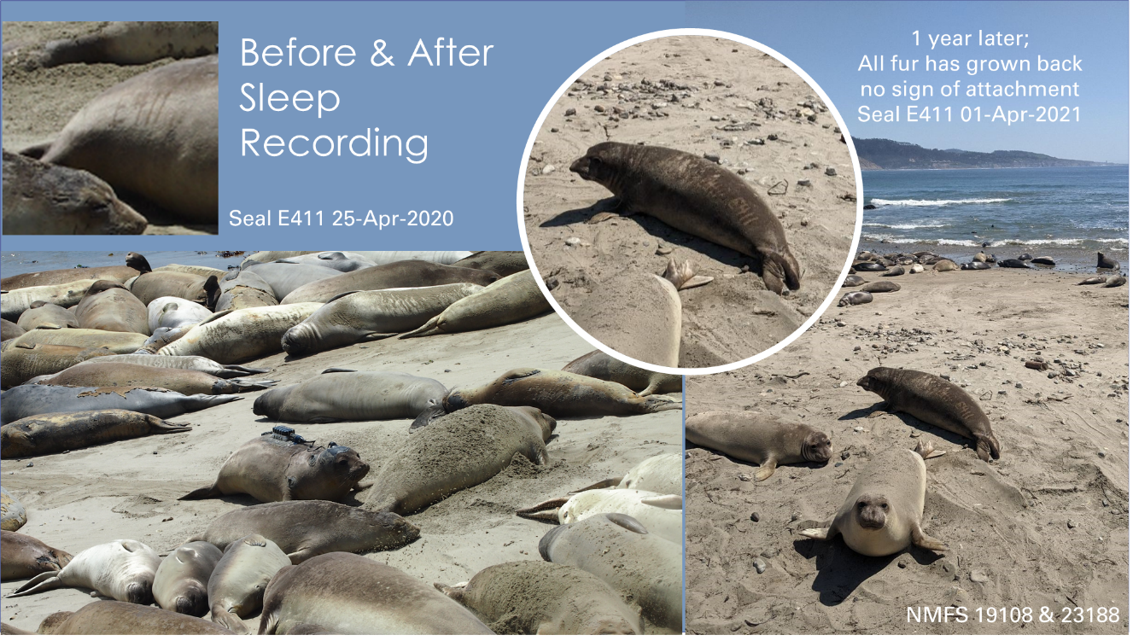**

### Tag Deployment

### Instructions for preparing tag for deployment

* 1. Preparing “frontend” (headcap, patches and cable harness):
     + 1. Cover exposed cables with nylon sheathing to protect from abrasion
       2. Use splicing tape and/or liquid electrical tape for additional abrasion resistance and attachment
       3. Set up cable-organizing Velcro bridges and prime with a layer of neoprene cement to facilitate adhesion upon attachment.
  2. Prepare logger & other tags for deployment and attachment:
     + 1. Use fiberglass mesh (screen repair tape) to prevent sand and dirt from getting into holes with pressure sensor and light sensor  
          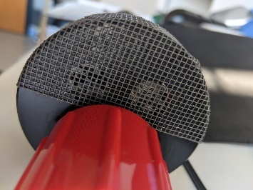
       2. Wrap logger with [tesa tape](https://www.amazon.com/Rolls-Tesas-Advanced-Harness-Mercedes/dp/B074YCG21Z/ref=sr_1_3?crid=2U06XWCNE2BR5&keywords=tesa+tape+automotive&qid=1653500907&sprefix=tesa+tape+automotiv%2Caps%2C202&sr=8-3) (this is required to avoid getting epoxy on tag and to facilitate tag removal after deployment - DON'T use splicing tape to wrap tag- will get cut by stainless steel zip ties)  
          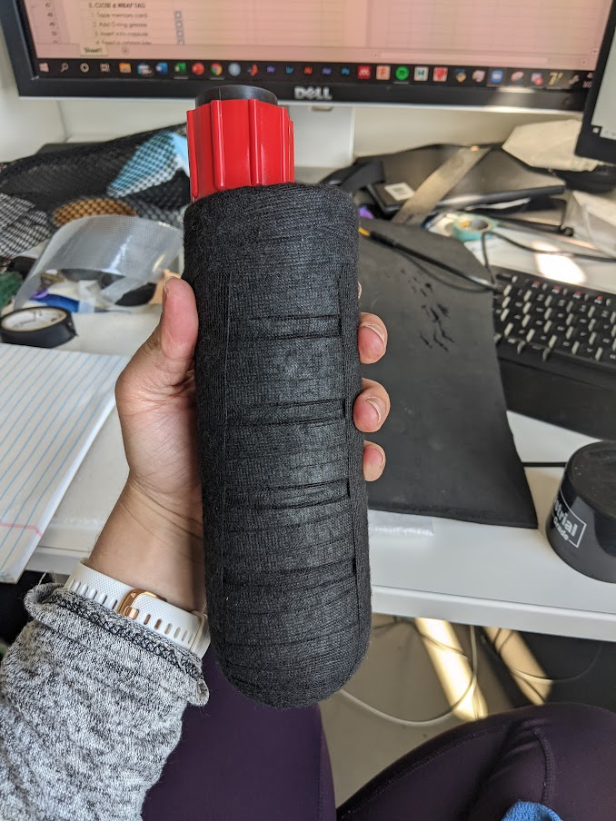
       3. Fasten logger to nylon mesh with stainless steel zip ties  
          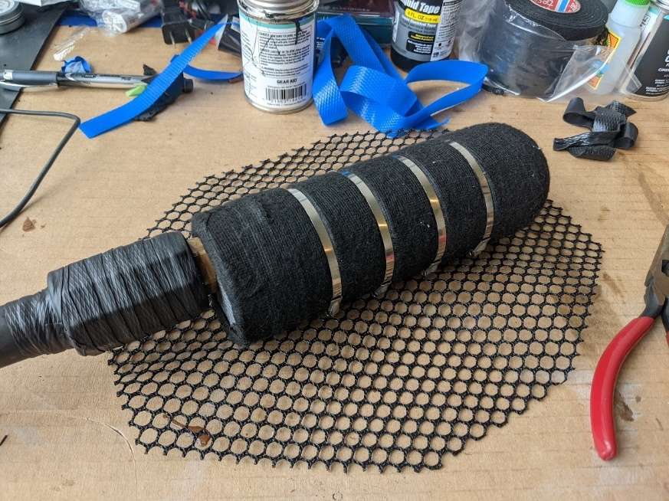
       4. Connect underwater connectors and screw on locking sleeve. Wrap this area with splicing tape or tesa tape to protect the plastic and connection.  
          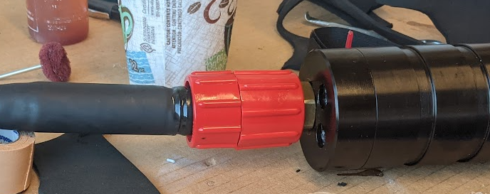
       5. Finished prepared assembly:   
          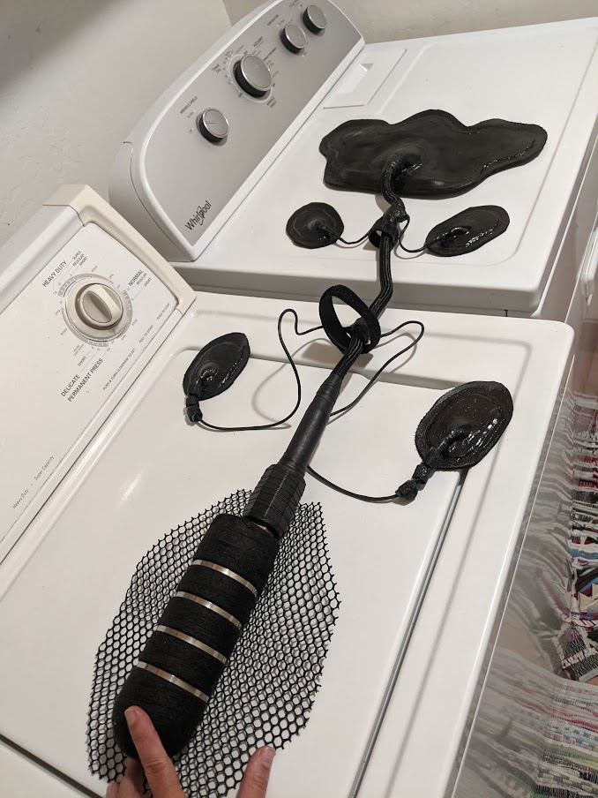 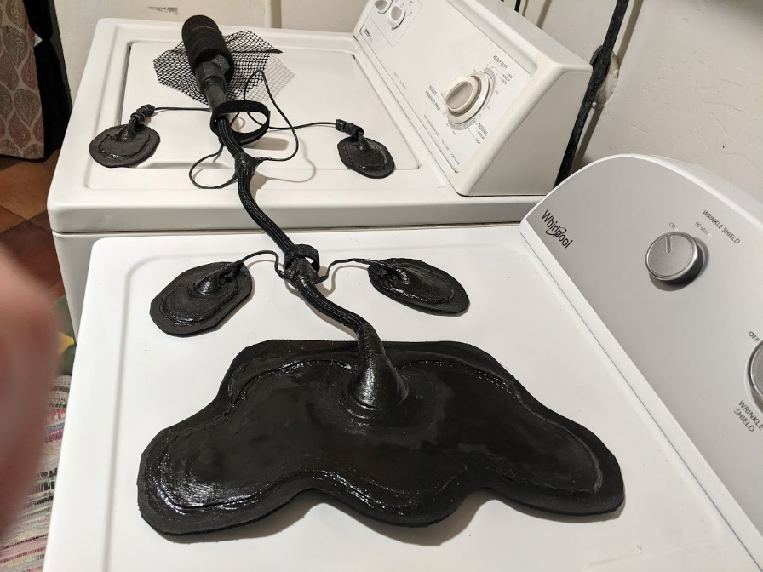
     1. Other (lighter) tags:
        1. Use robust fishing line and plastic zipties to connect the tag to the nylon mesh

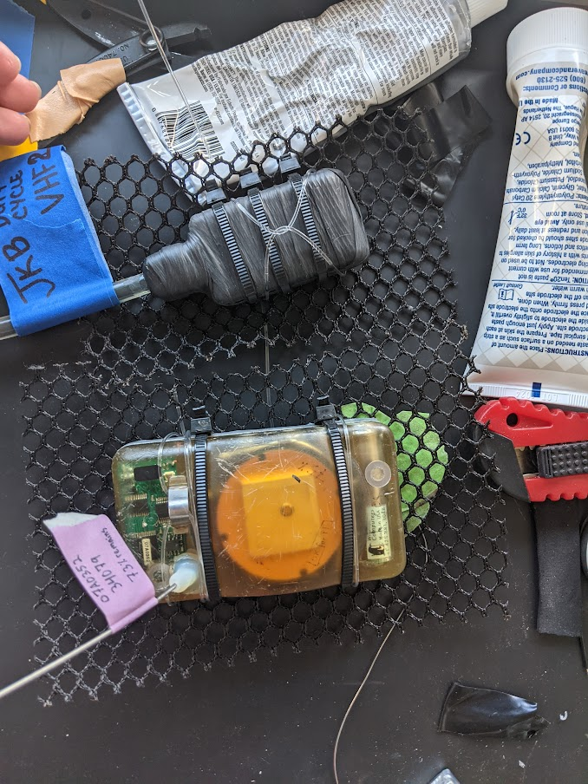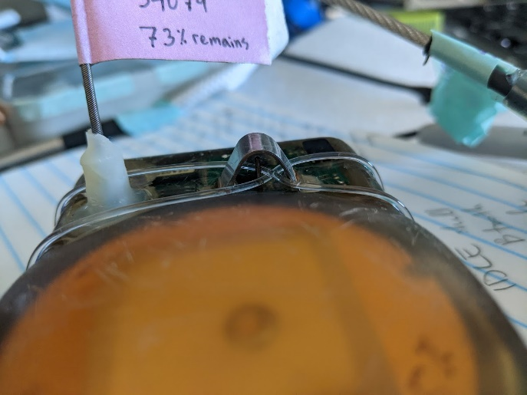

You can use the temperature sensor of a Wildlife Computers tag to wrap the fishing line around (see photo above), but avoid putting any strain on the temperature probe itself.

* + - 1. Trim off excess nylon mesh (leaving ~3-4 cm around the tag footprint, depending on the weight and shape of the tag).
      2. For thick, rigid fishing line, you can use a spot of superglue to keep the knot from coming undone:

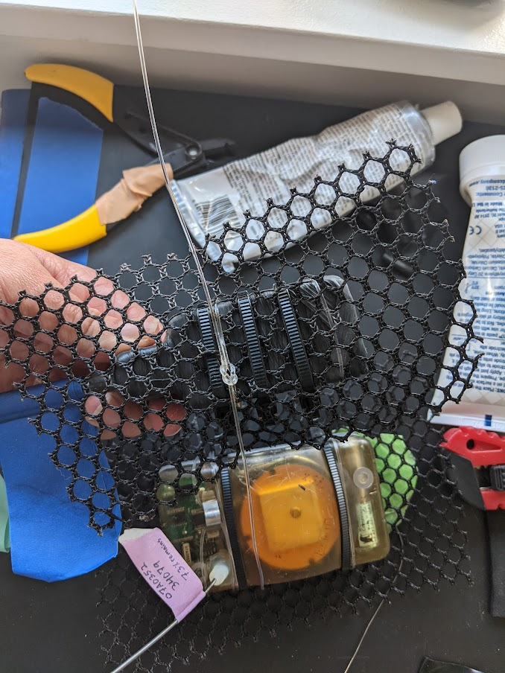

* + - 1. 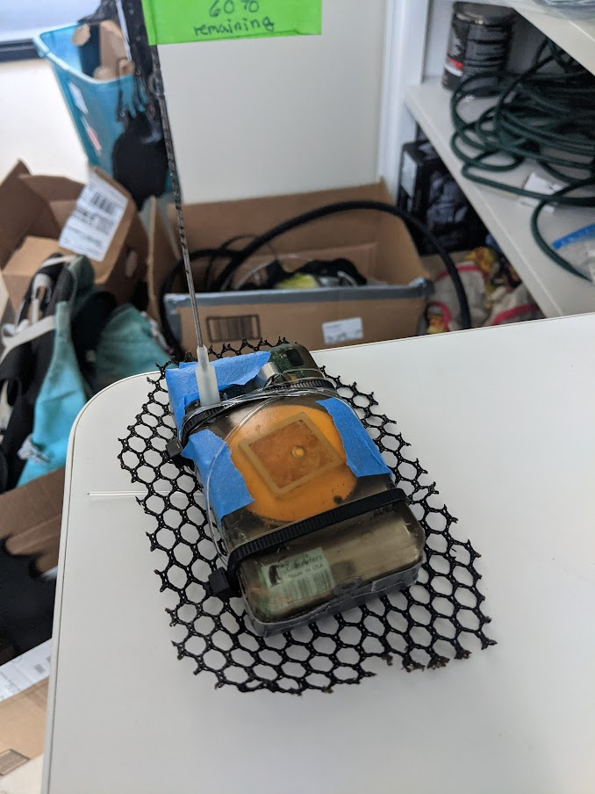 Tape depth and wet-dry sensors to avoid getting any epoxy on them (see photo to the left).
      2. Keep the wrapped tags away from magnets to avoid accidentally turning them off after switching them on.

### Gear Checklist

**For Lead Researcher to bring:**

* + - 1. Wrapped Neurologger (logger and front-end)
      2. Wrapped MK10 (no magnets nearby)
      3. Wrapped VHF (no magnets nearby)
      4. Splicing tape, electrical tape, and NexCare tape
      5. Superglue & E6000
      6. Extra clipper blades
      7. Neoprene cement (bottles and tubes)
      8. Silicone templates (headcap & patch)
      9. Camera (charged with blank SD card)
      10. Tripod for camera (with extra tape)
      11. Webcam (with blank SD card), USB, & powerbank
      12. Snips of all shapes and sizes
      13. Datasheets and clipboard
      14. Watch with seconds, attached to clipboard

**Gear Checklist (for animal handler to bring):**

* + - 1. Scale & Come-along
      2. Drugging supplies
      3. Blood collection supplies
      4. Girth rope & measuring tape
      5. Ultrasound: gel, brush, phone
      6. Clippers (2), extra battery
      7. Alcohol and rags
      8. Epoxy (~10X/procedure) & paper cups and popsicle sticks to mix and apply epoxy
      9. Extra sharpies
      10. Printed procedure datasheets
      11. Printed candidate list

### Attachment instructions

* + 1. 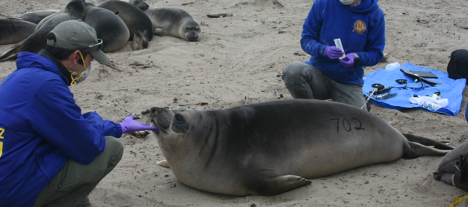Before animal sedation, **prep electrodes** by filling goldcups with a small ball of conductive paste (Ten20)
    2. Set up video cameras to record procedure.
    3. **Sedate animal** (elephant seals: ~1mg/kg)
    4. **Monitor the animal’s status** as it goes down (photo to the right)
    5. Once the animal is down, brush any sand, dirt off of animal
    6. **Mark outlines** of headcap, EMG/ECG patches, and logger footprint (outside of nylon mesh) with sharpie – use the entire assembly to make sure that wires have enough play and are rotated in such a way that will not add additional strain  
       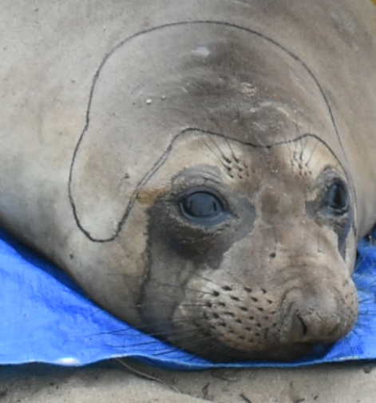 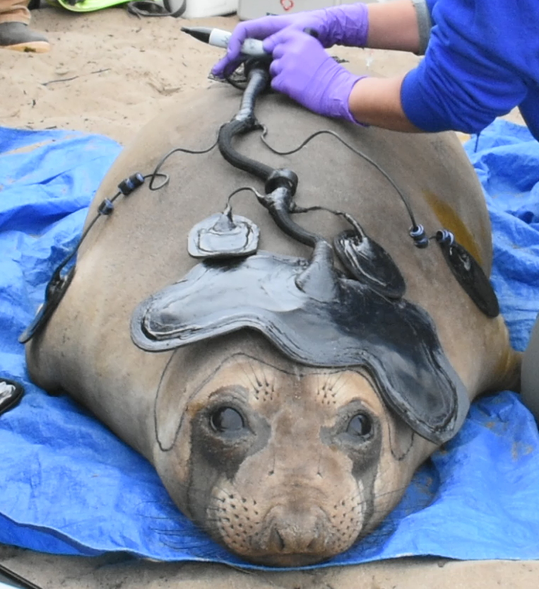 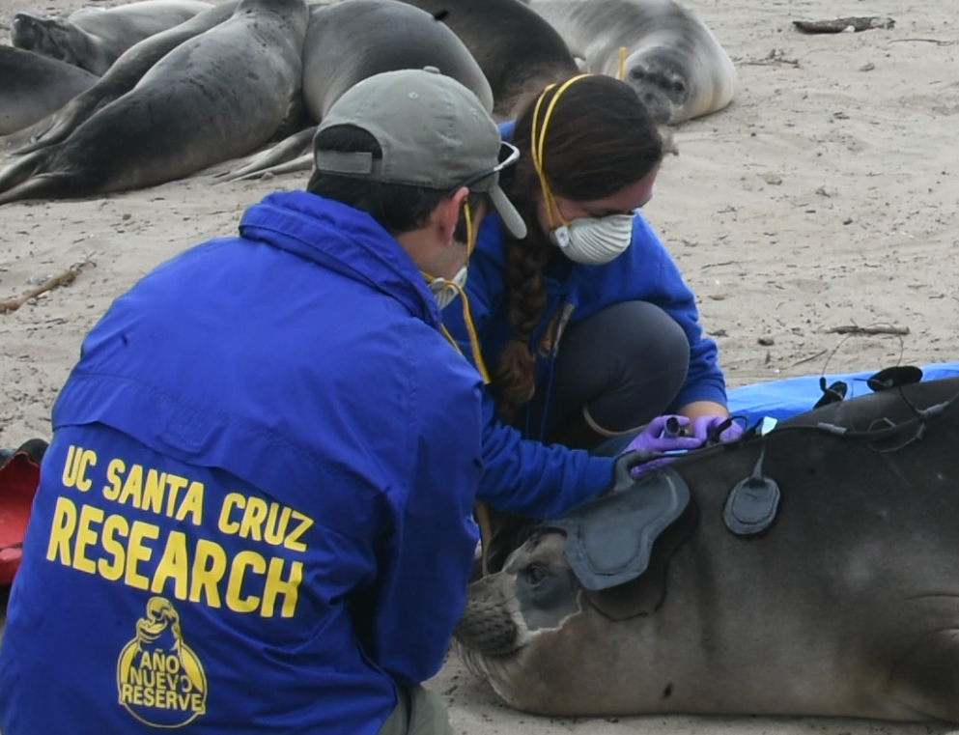
    7. Secure the supra-orbital vibrissae out of the way of shaving and glue with tine tape or NexCare tape.
    8. Shave fur with a 40-blade clipper within patches for headcap, EMG/ECG, but NOT the logger footprint (the fur is important for the epoxy to bond well). Shave a footprint ~1/2” larger than the tag itself, so that you can get a good bond to the skin around the footprint of the tag.
    9. Ultrasound the head to measure skull thickness around the fronto-parietal region of either hemisphere (see region indicated in the image below)
    10. Clean shaved regions with alcohol and a rag
    11. Use the headcap with electrode paste (and/or a headcap template with holes) to mark the location of the electrodes on the skin with a sharpie – you’ll use this to avoid these locations when applying a layer of glue to the skin.  
        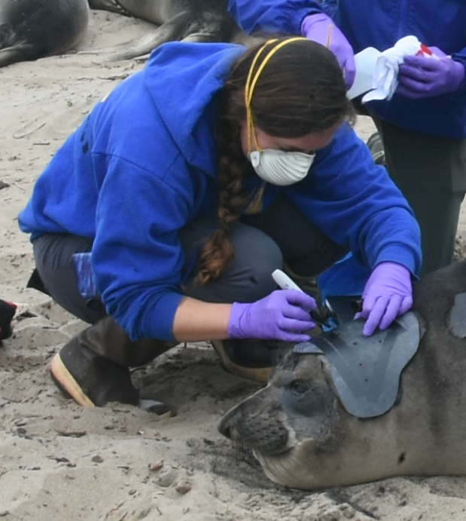
    12. Attach headcap and patches:
        1. First, apply neoprene cement (AquaSeal brand [more reliable shipping time] or Trident brand [cheaper]) to the headcap everywhere except for the electrodes themselves  
           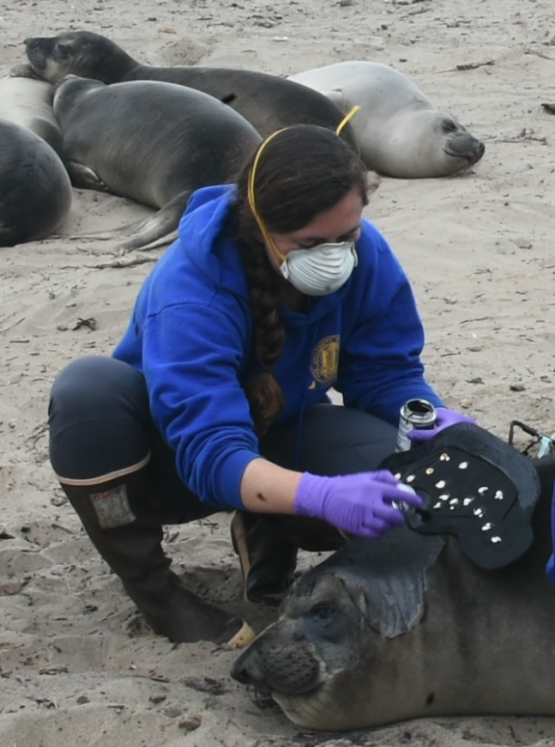
        2. While someone is doing step 1, someone else can begin to apply neoprene cement to the seal’s skin, making sure to avoid (~2-3 cm radius) each electrode position.

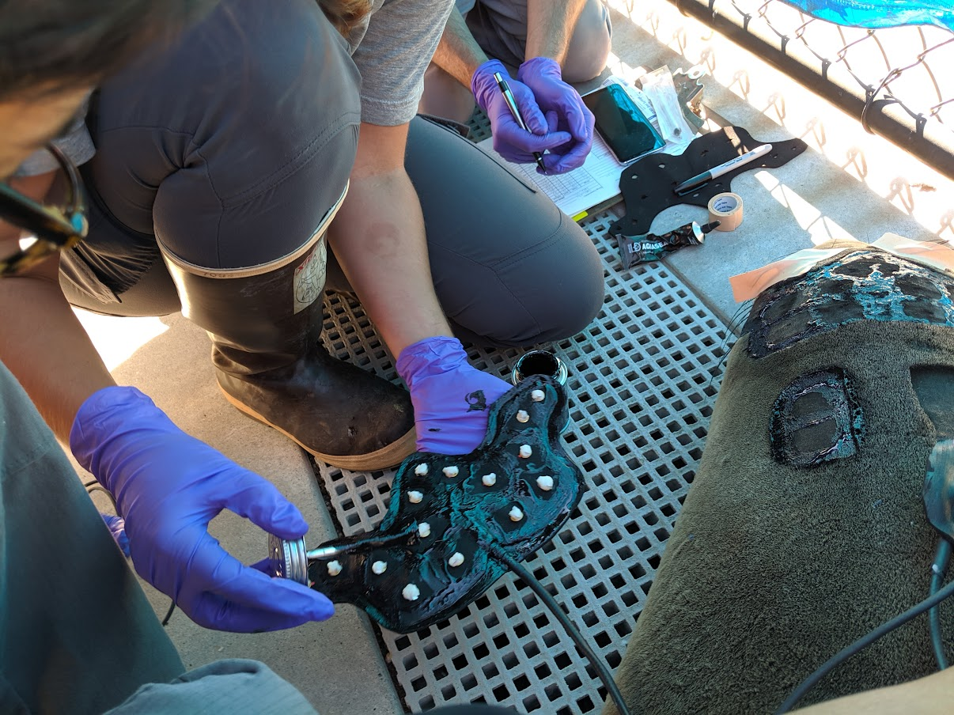

* + - 1. Once neoprene cement has been applied to both the headcap and the animal (see photo above), wait ~5 min for the neoprene cement to become tacky. It should not be wet to the touch, instead it should look dry and dull and will grab your fingers more if you touch it. At that point, you can *very carefully* descend the headcap onto the footprint. ***This is tricky.*** Make sure to start at the back of the head, roll forward, while two different people have each side of the headcap to make sure that the headcap does not extend past the sticky footprint of glue on the animal. As you press the headcap down, apply a bit of pressure to ensure that the conductive paste spreads and makes good contact between the skin and the electrode within the cap.  
           
         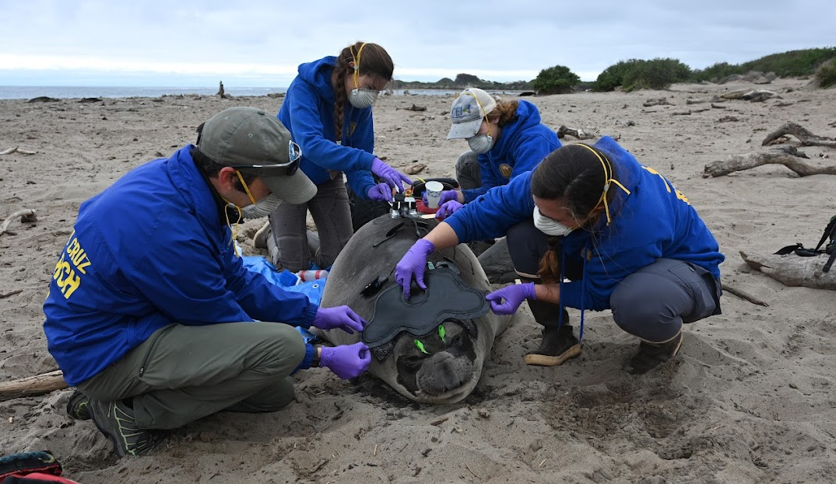
      2. Use this same method (neoprene cement on neoprene and animal (avoiding electrode locations), wait, and then stick the two pieces together) for each of the patches.
      3. Once the patch is on the animal, focus your attention to the edges of the headcap and patches:
         1. First, apply small dots of superglue every ~5cm along the periphery of the headcap, between the outer layer of neoprene foam and the neoprene cement on the skin of the animal.
         2. Before this dries, use a nearly-finished can of neoprene cement to apply neoprene cement over this superglue, around the entire perimeter of each patch. The brush will become a bit sticky and gross- you can keep using this brush only for spreading the neoprene cement over superglue areas.
         3. As the neoprene cement becomes wet again, the periphery of the headcap and patches may lift up. Press these edges down once the neoprene cement becomes dry and dull looking. It will stick better when it has been exposed to air for a bit of time.
         4. If needed, place additional neoprene cement where there was not enough between the headcap and the skin. The edges are critical- once they come up, they will keep peeling and adding drag and resistance to the animal.   
            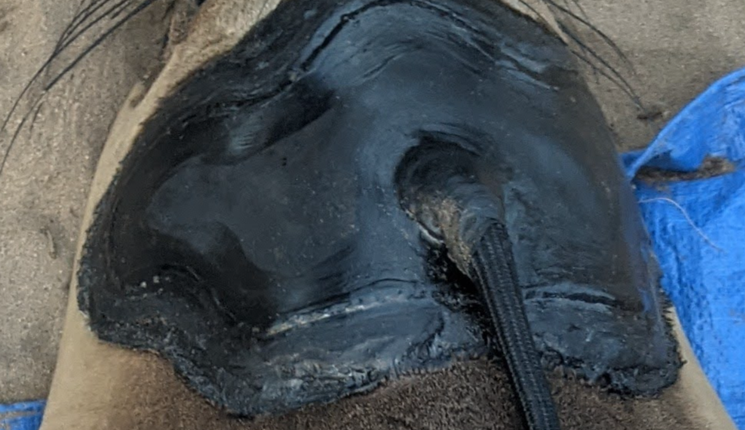
      4. Attach and fasten cables with Velcro cable organizers:
         1. Plan out the location of these cable organizers: make sure to allow for enough play for the animal to move while swimming, especially allowing the animal to arch its back and for its flippers to reach towards each other.
         2. Apply neoprene cement to both the cable organizer and the fur of the animal, wait for it to dry, and press the two pieces together.   
            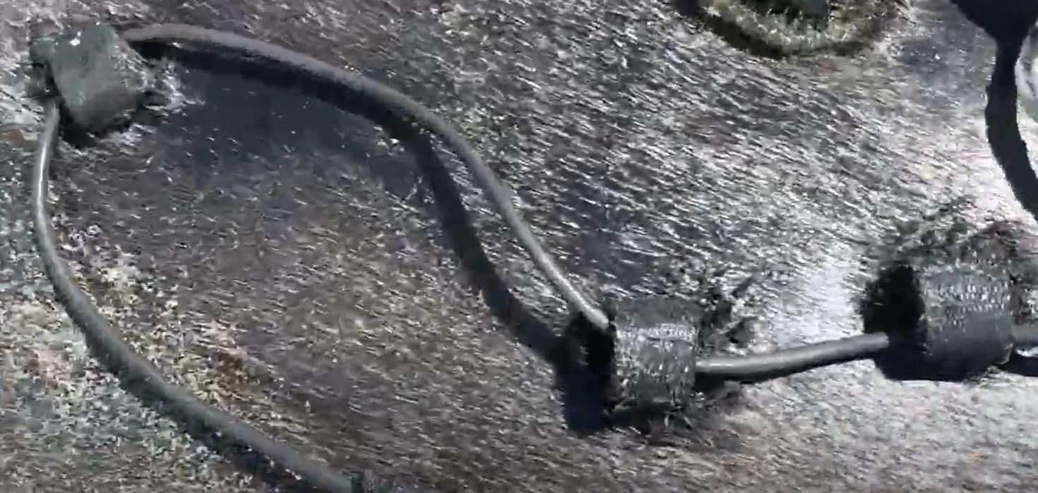
    1. Attach tags with epoxy (can happen simultaneously with sleep tag attachment above)
       1. Before/during procedure, keep epoxy warm by putting it in a pocket close to the body (especially in cold working conditions such as Antarctica) – this will make it easier to mix later on
       2. Use the sharpie outline to find where to clean
       3. Clean fur with acetone or alcohol (we use acetone with elephant seals)
       4. Mix up the 2-part QuickSet epoxy from Loctite in a paper cup with a popsicle stick
       5. Apply epoxy to the nylon mesh under the tags and within the sharpie outline on the fur of the animal – make sure to have adequate coverage, but also not to place too thick a layer, which will create a larger rigid volume and may generate a lot of heat when it cures.
       6. Once the epoxy has been spread on both areas (under tag and on animal), place the tag down in the footprint on the animal. ***Do not remove your hand from the tag-*** keep light downward pressure (mostly keeping the tag in place) until the glue dries. Be careful not to apply too much downward pressure at this stage (especially for cylindrical tags), which might cause the tag to uncomfortably press into the animal’s body once rigid.
       7. Place additional epoxy on the upper side of the nylon mesh and use a popsicle stick to push the nylon mesh down as the epoxy starts to cure.
       8. Repeat this process for each of the tags that must be attached with mesh AND the large Velcro cable organizer placed just anterior of the logger (see image below).
       9. Overall configuration   
          *Note: when configuring other tags, the position of the satellite tag will affect how many hits you get. This configuration yielded a few hits (we had to move the sleep tag to the side to avoid a wound so could put the satellite tag up higher on the animal):  
          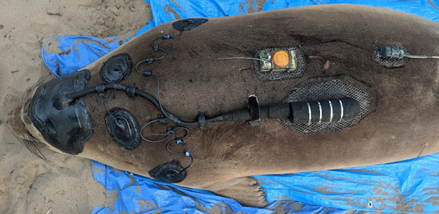
    2. Let seal recover, monitor seal’s status  
       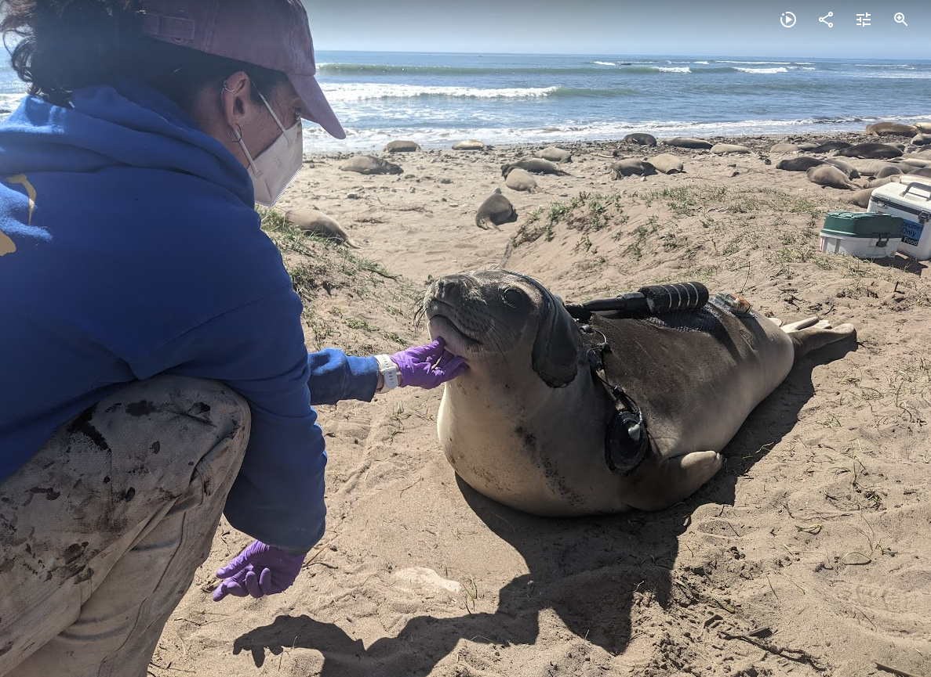
    3. Observe seal & record ~2 h of video post-procedure.

### Tag Recovery

### Gear Checklist

**For Lead Researcher to bring:**

* + - 1. **Snips of all shapes and sizes – MOST IMPORTANT, make sure to bring robust stainless steel snips (I recommend these) to cut through stainless steel zip ties**
      2. **Needle-nose pliers** to grab and remove the stainless steel zip ties from the mesh upon removal
      3. Camera (charged with blank SD card)
      4. Tripod for camera (with extra tape)
      5. Webcam (with blank SD card), USB, & powerbank
      6. Datasheets and clipboard
      7. Watch with seconds, attached to clipboard

**Gear Checklist (for animal handler to bring):**

* + - 1. Scale & Come-along
      2. Drugging supplies
      3. Blood collection supplies
      4. Girth rope & measuring tape
      5. Alcohol and rags
      6. Extra snips
      7. Printed procedure datasheets

### Removal instructions

* + 1. Before animal sedation, set up video cameras to record procedure.
    2. **Sedate animal** (elephant seals: ~1mg/kg)
    3. **Monitor the animal’s status** as it goes down
    4. Once the animal is down, take photos of the animal and the instrument attachment (before removal)
    5. Removal may begin:
       1. Headcap/patch removal:
          1. Carefully cut between the two neoprene layers of the headcap (below the neoprene rubber and above the neoprene foam)
          2. Use your fingers to separate the two neoprene layers and begin to peel the neoprene rubber up and away from the neoprene foam. When you encounter the silicone RTV adhesive and/or electrodes, carefully avoid pulling on these electrodes or materials. Instead, work your way around them along the neoprene rubber.
          3. Once the neoprene rubber, and electrodes are safely removed from the animal, you can attempt to peel away the neoprene foam below. In some cases, this is done very easily and can leave the shaved patches looking very clean:  
             *Example of a weanling removal procedure where we prioritized removing as much material as possible since her next molt will be next year:*  
             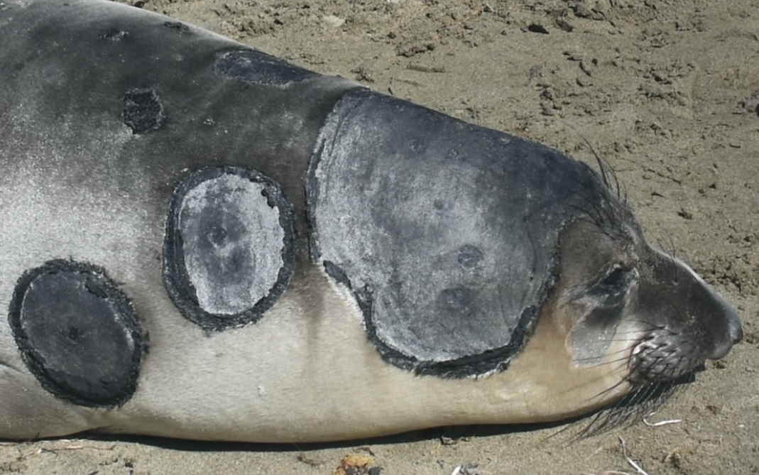 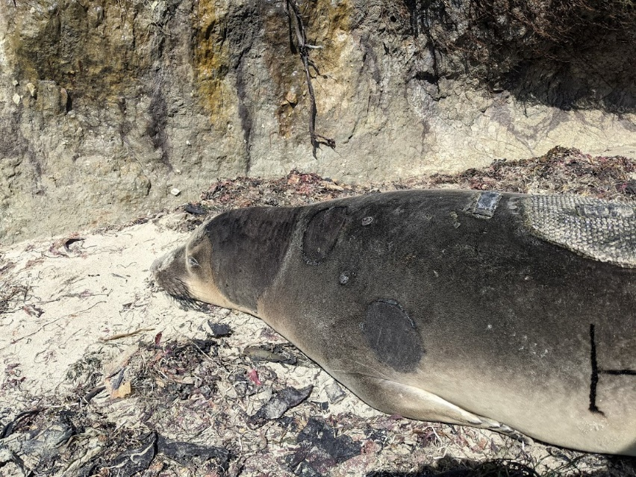  
               
             In other cases, this peeling may be difficult and, especially in the case of juvenile elephant seals that will molt shortly, may be unnecessary considering they will molt within a week or two. In that case, we recommend leaving neoprene residue on the animal and letting it molt it off along with its skin and fur:  
             *Example of an animal post-removal where we left some neoprene residue & that same animal 20 days later when it was molting:*  
             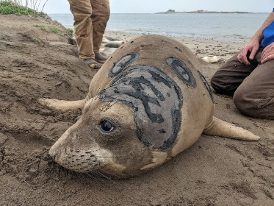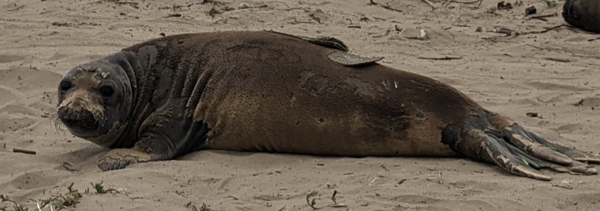
       2. Sleep tag removal:
          1. Cut metal zip ties with robust, stainless steel snips- These can and have broken smaller snips so do not try to use smaller wire-cutter snips for this. However, be careful not to damage the anodize layer on the tag while you do this. This layer helps protect the tag from corroding over time.
          2. Cut through the tesa tape with smaller snips or scissors. This also may be a bit difficult, but try to avoid damaging the anodize layer on the tag while you do this.
          3. Once the tesa tape is cut through, you should be able to peel the tag up and out of the nylon mesh still stuck to the animal.
          4. You can clean up what is left on the animal by removing the metal zip ties, cutting back the tesa tape and leaving only the epoxy nylon mesh patch and other cable organizers:  
             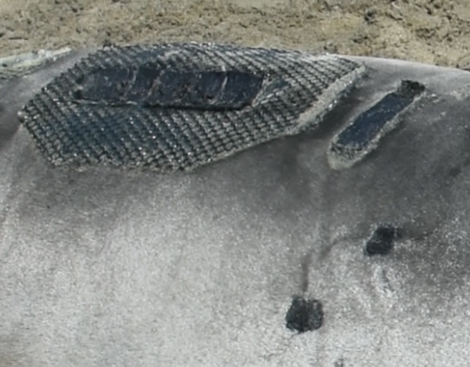
          5. The animals will then molt off this patch along with the rest of their skin and fur (see example photo above).
       3. Other tag removal:
          1. Same as above, cut through plastic zip ties, remove as much material as possible, and leave the epoxy patches for the animal to molt off.